  
  
  
  
  
Production Executive System

User Manual

Contents

1. General Information 4

2. Login Page 5

3. 3.Home Page 6

4. Admin Module 8

User Maintenance 8

Shop Floor Maintenance 10

Production Line Maintenance 12

Reason code 13

Machine Maintenance 14

Shift Maintenance 16

Quality Attribute Maintenance 17

Quality Test Plan 19

Work Order Detail Viewer 25

Work order Test Plan Mapping 27

Clone Recent Mapping 30

Example Workflow 30

Holiday 32

Production Line Status 33

Scheduling Work Bench 43

17. Job Travel Card (JTC Report) 57

16. Quality Assurance - Observation and Analysis 61

1. Job Order Testing Procedure 62

1.1. Test Samples 62

2. Component Tracking 63

2.1. Recording Components 63

2.2. Additional Information 64

3. Testing Details 64

3.1. Test Description 64

3.2. Entering Test Results 65

3.3. QA Completion and Record Management 66

3.4. Actual Time Recording 67

3.5 Report Downtime 68

3.6 Report Production and Rejected Quantity 69

18. Shop Floor Viewer 71

Shop Floor Metrics Formulas 73

Data Display Overview 74

# General Information

This document explains how to use Production Executive System (PES) on daily basis for monitoring the manufacturing industry.

# Login Page

Production Executive System (PES), can be accessed using the provided URL in any web browser. Registered users can log in with their credentials. The Application Admin can create new users and update existing user profiles.  
  
<https://pes.digitusbiz.net/>



# 3.Home Page

* On successful login, user will be on home page of the application as shown below.  
    
  
* Click on the right corner so that you can view all the modules available. In addition, under Admin modules sub modules can be viewed based on the logged in user’s user role as shown in below images.

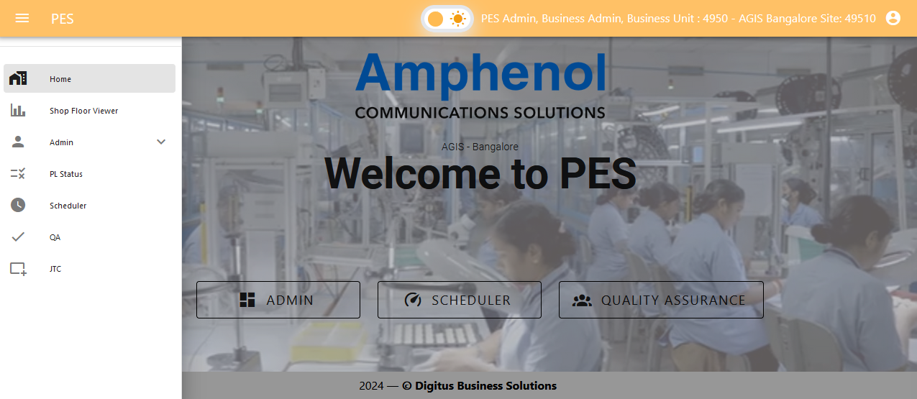

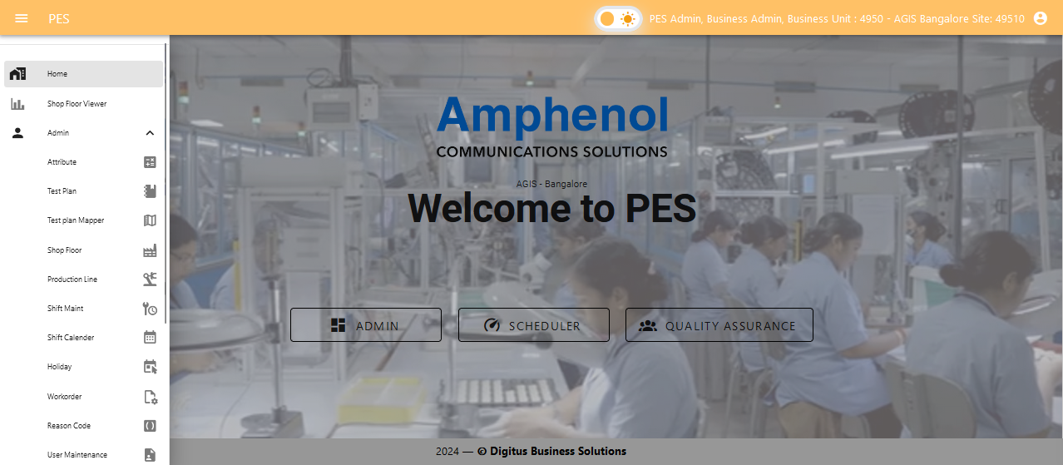

# Admin Module

General Information

In the Admin Module, users can:

* **Add (+)**: Create new records. Success and error messages will be displayed, and the new record will appear in the view table (only for User Maintenance).
* **Create**: Create new record with the mandatory entries and Save.
* **Edit (🖉)**: Modify existing records. Success and error messages will confirm the update, with the edited record shown in the view table.
* **Delete ()**: Remove records if they are not linked to other data. A confirmation message will be displayed upon successful deletion, and the view table will be updated. Errors will be shown if there are issues with linked records.
* **Save**: Save changes made to records. A success message will confirm that the changes have been saved. If there are errors, an appropriate error message will be provided.
* **Cancel**: Discard any unsaved changes and return to the previous state. No changes will be saved.

## User Maintenance

In this module, you can:

* : Creates new user.
* **Edit**: Modify existing users.

Additionally, manage user roles, which define access limitations within the application. For example, roles like Engineer and Team Leader etc., will have restricted access to Shop-Floor and Line Master, which can also be added and edited in this module. Users will use their username and password to log in to the application.

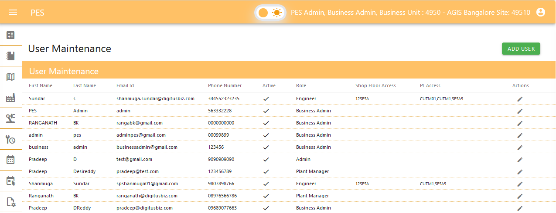

|  |  |
| --- | --- |
| 1. User role List | 1. Shop Floor List |

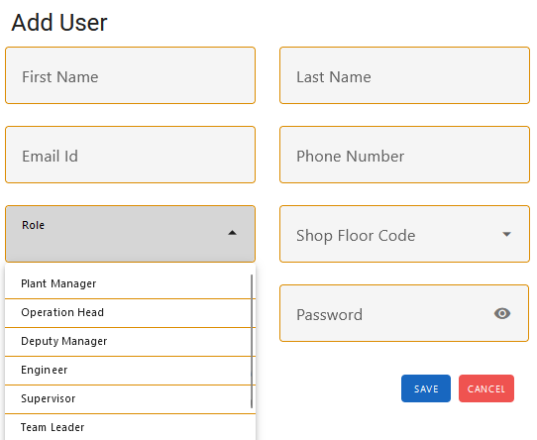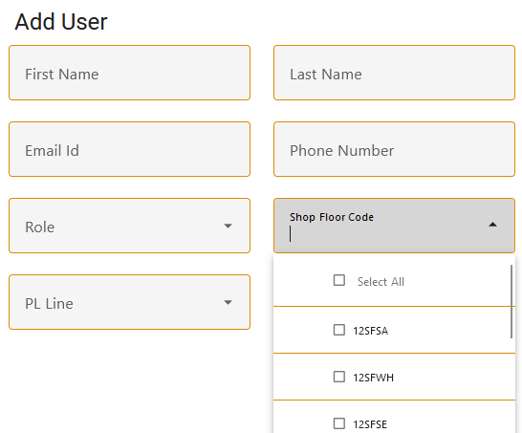

* Line Master List

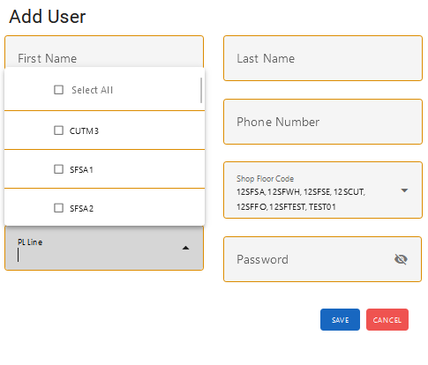

* **User role – Access Matrix**

## 

## Shop Floor Maintenance

In this module, you can:

* **Save**: Create new shop floors with a unique name and code.
* **Edit**: Modify existing shop floors.
* **Delete**: Remove shop floors, provided they are **not linked with any Line Master.**

Each shop floor must be associated with a Line Master and must have a unique shop floor name and shop floor code.

* **View Shop Floor**

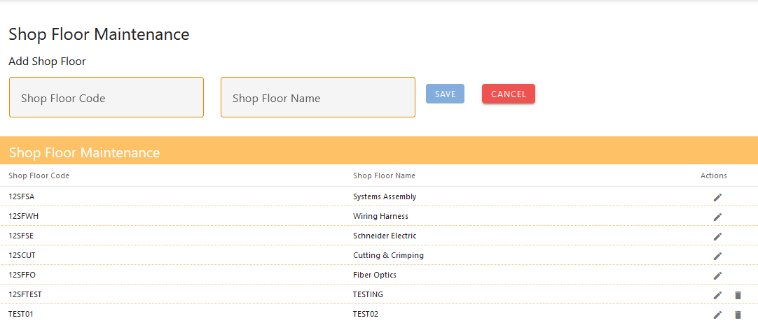

* **Edit Shop Floor (only on shop floor name)**

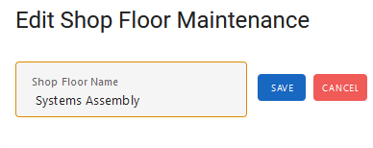

## Production Line Maintenance

In this module, you can:

* **Save**: Create production lines under a shop floor.
* **Edit**: Modify existing production lines.
* **Delete**: Remove production lines only **if no job orders are planned on that production line.**

Additionally, you can specify details for each production line, including the item family that can be used, units per hour, and the setup time required.

* **Add & View Table**

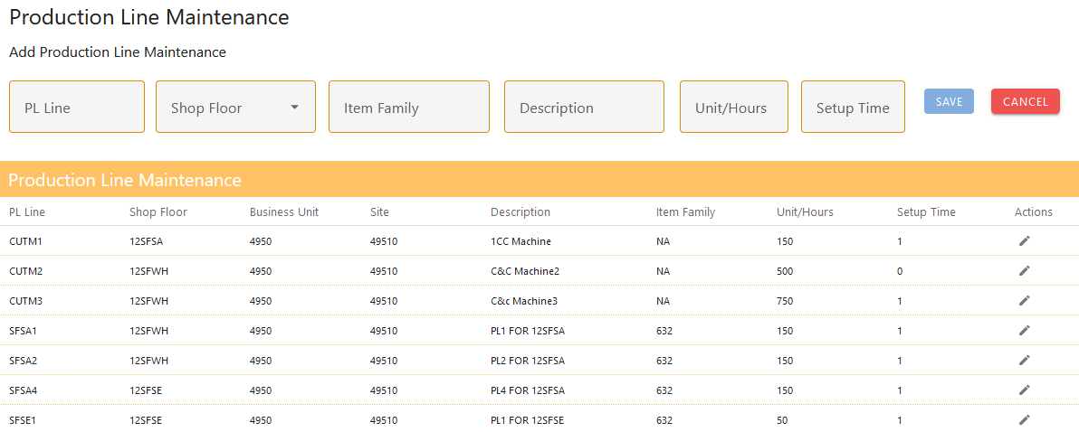

* **Edit Production Line**

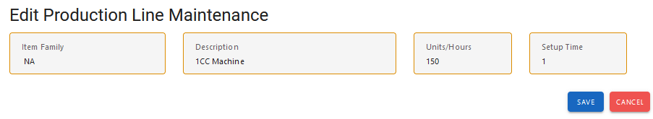

## Reason code

In this module, you can:

* **Save**: Create new reason codes.
* **Edit**: Modify existing reason codes.
* **Delete**: Remove reason codes only if they are not in use.

Additionally, you can specify details for each reason code, including its type for generic use in multiple modules and a description.

* **Add & View Table**

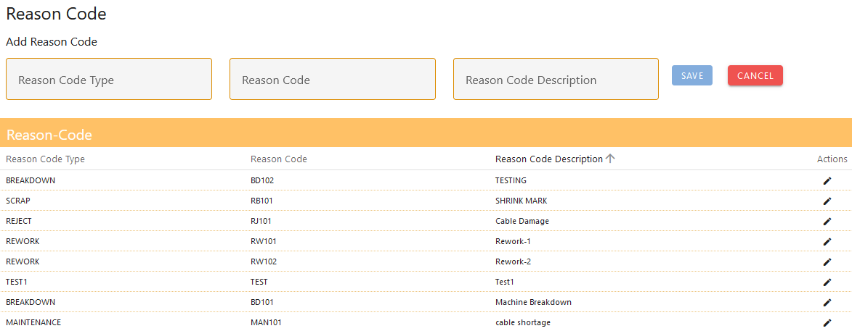

* **Edit**

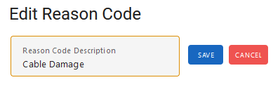

## Machine Maintenance

In this module, you can:

* Save: Create new machines for operations.
* Edit: Modify existing machines.
* Delete: Remove machines only if they are not in use.
* **Create new machine & View table**

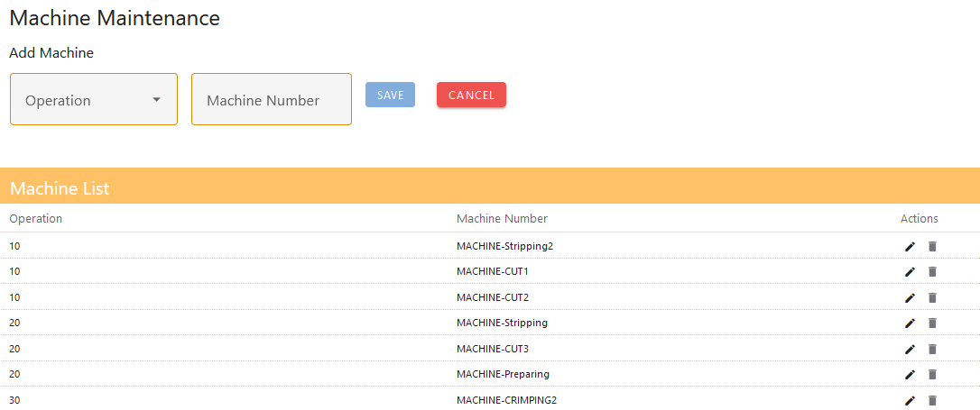

* Edit

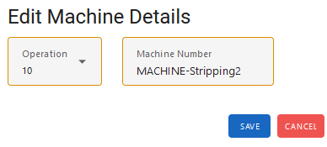

**Applicator Maintenance**  
In this module, you can:

* **Save**: Create new applicators for an operation and specify the machine used in that operation.
* **Edit**: Modify existing applicators and update their associated machine and operation details.
* **Delete**: Remove applicators as needed
* **Create new applicator & View Table**

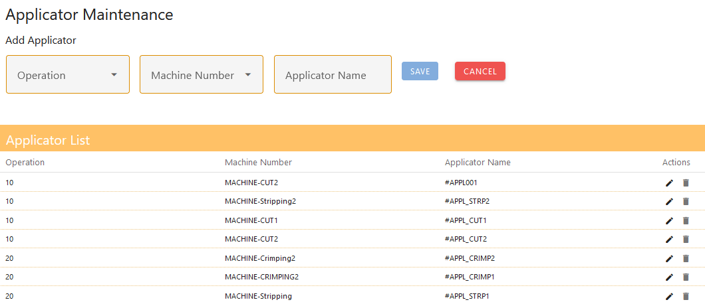

* **Edit**

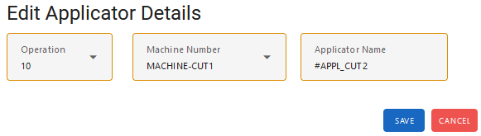

## Shift Maintenance

In this module, you can:

* **Edit**: Adjust shift hours and the shift start time. The end time of the shift is automatically calculated as the start time plus the shift duration.
* For example, if the shift hours are set to 8 and the start time is 07:00:00, the end time will be 15:00:00.
* This records will be considered as the shift timing and used for scheduler and production line status entry.
* **View Table**

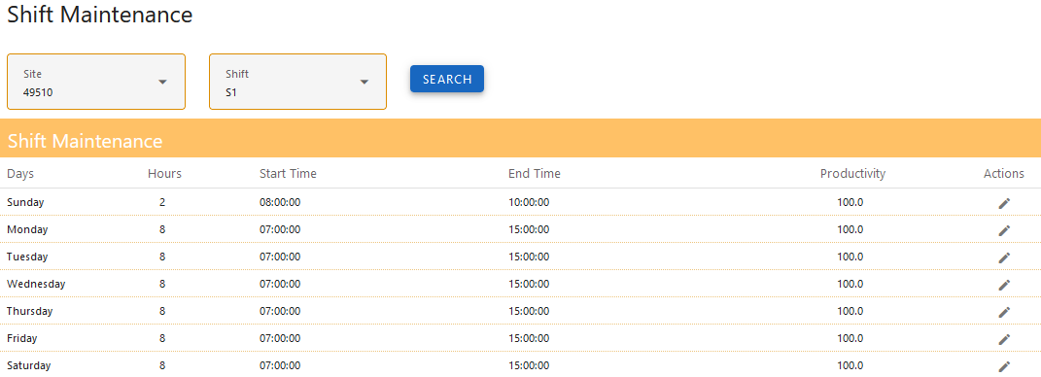

* **Edit**

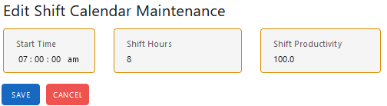

## Quality Attribute Maintenance

In this module, you can:

* **Create**: Add new attributes, which can be of two types:
  + **Numerical**: Includes inputs for unit type (cm, m) and decimal format (number of decimal places).
  + **Logical**: Includes a logical format (e.g., Y/N, OK/NOK).
* **Edit**: Modify existing attributes, with the restriction that the attribute type cannot be changed.
* **Delete**: Remove attributes only if they are not used in any test plans.
* **Create new attribute and View Table.**
* **Numerical Attribute**

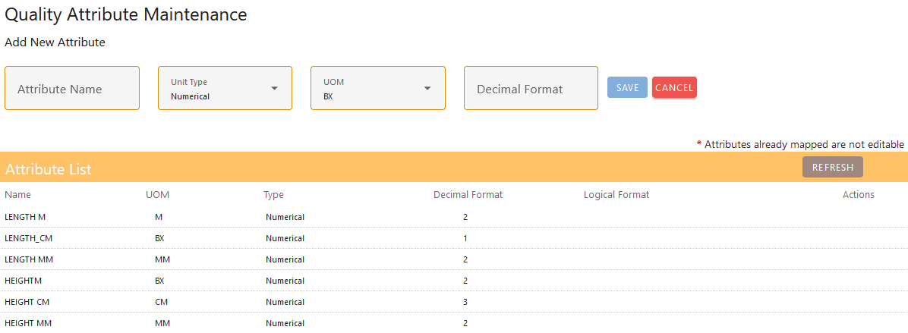

* **Logical Attribute**

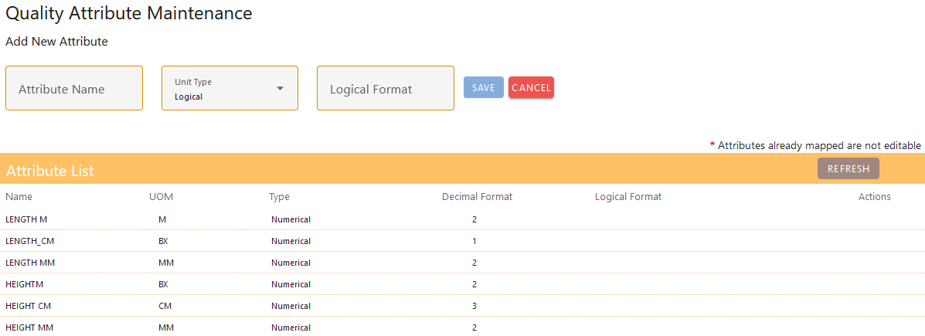

* **Edit**

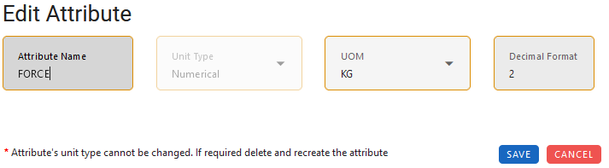

## Quality Test Plan

#### ****Test Plan Creation****

* **Item Name:** [Input Field for Identification]
  + This will serve as the unique identifier for the test plan.

#### ****Adding Attributes****

* **Numerical Attributes:**
  + **Description:** [Input Field]
    - A brief explanation in the text field.
  + **Reference Value:** [Input Field]
    - The default or standard value for the attribute.
  + **Upper Limit:** [Input Field]
    - The maximum allowable value.
  + **Lower Limit:** [Input Field]
    - The minimum allowable value.

Example:

* + Attribute: Length
    - Reference Value: 2.6cm
    - Upper Limit: 0.1cm
    - Lower Limit: 0.1cm
* **Logical Attributes:**
  + **Description:** [Input Field]
    - A brief explanation in the text field.
  + **Reference Value:** [**Checkbox**]
    - If checked, the test should be conducted as a positive case.
    - If unchecked, the test should be conducted as a negative case.

Example:

* + Attribute: Power On Status
    - Positive Case: [Checked]
      * Indicates that the item should be tested to confirm it powers on correctly.

#### ****Editing Attributes****

* **Editing Process:**
  + Edits can be made to the attributes within the test plan.
  + **Note:** Changes will not affect existing work order mapping & test results. They will only be applied to future tests.

#### ****Deleting Attributes****

* **Deletion Process:**
  + Click on the delete button on the end of the row.
  + Also, Deletion of attributes follows the same process as editing.
  + **Note:** Once attribute deleted, they will no longer appear in future tests.
* Creation of new Test Plan Name

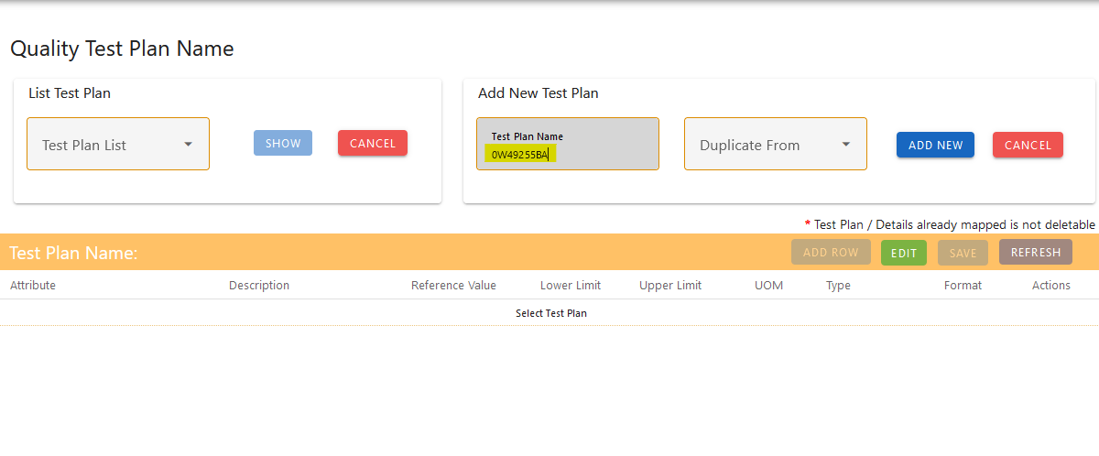

* Clone of new Test Plan with existing test plan (Duplicate Form is a drop down will list all the existing test plan name)

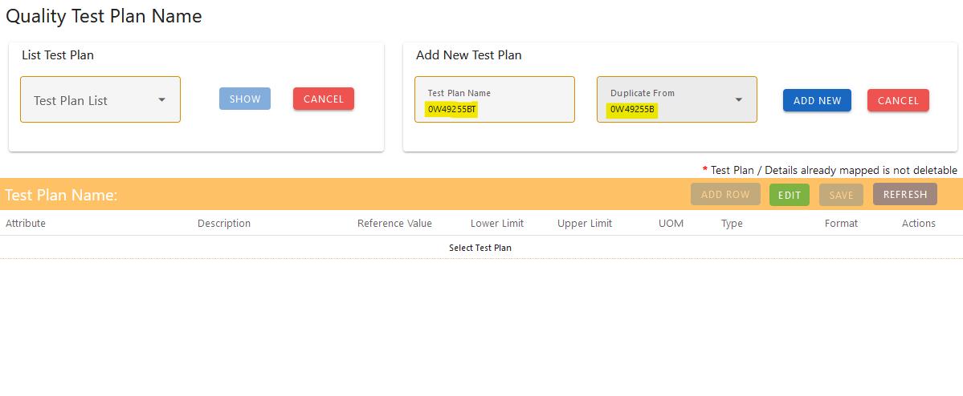

**Excel Upload for New Test Plan**

* **Template Download:**
  + **Download Template:** [Button to Download Excel Template]
    - Provides a pre-defined Excel template for entering attributes.
    - The template includes fields for Attribute, Description, Reference Value, Upper Limit, Lower Limit

Template Columns:

* + **Attribute Name (should be present as Quality Attribute. Also check for spelling)**
  + **Description**
  + **Reference Value** (for Numerical attributes)
  + **Upper Limit** (for Numerical attributes)
  + **Lower Limit** (for Numerical attributes)
  + **Reference Value** (for Logical attributes, with 1 or 0 where 1 considered as positive case and 0 considered as negative case)
* **Upload Excel File:**
  + **Upload Button:** [Button to Upload Excel File]
    - Allows users to upload the completed Excel file.
    - File must adhere to the downloaded template format.
* **Validation and Import:**
  + **Validation:** The system will check the uploaded file for correct formatting and required fields.
  + **Import:** If validation is successful, the attributes from the Excel file will be imported into a new test plan.

Error Handling:

* + **Error Messages:** Provide specific error messages if the file format is incorrect or required fields are missing.

Example:

* + **Uploaded File Content:**

**For Numerical Attribute**

* + - **Attribute Name:** Voltage
    - **Reference Value:** 220V
    - **Upper Limit:** 0.01V
    - **Lower Limit:** 0.01V

**For Logical Attribute**

* + - **Attribute Name:** Colour
    - **Reference Value:** 1 (Yes)

* + - **Excel to be uploaded**

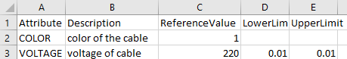

* + - **Imported data from the uploaded excel**

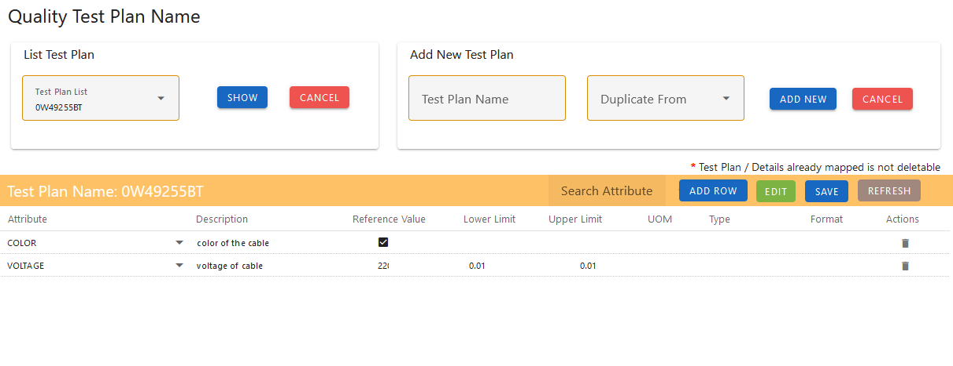

**Add Attributes for a Test Plan**

* To add the quality attributes for new or existing test plan from the test plan screen.

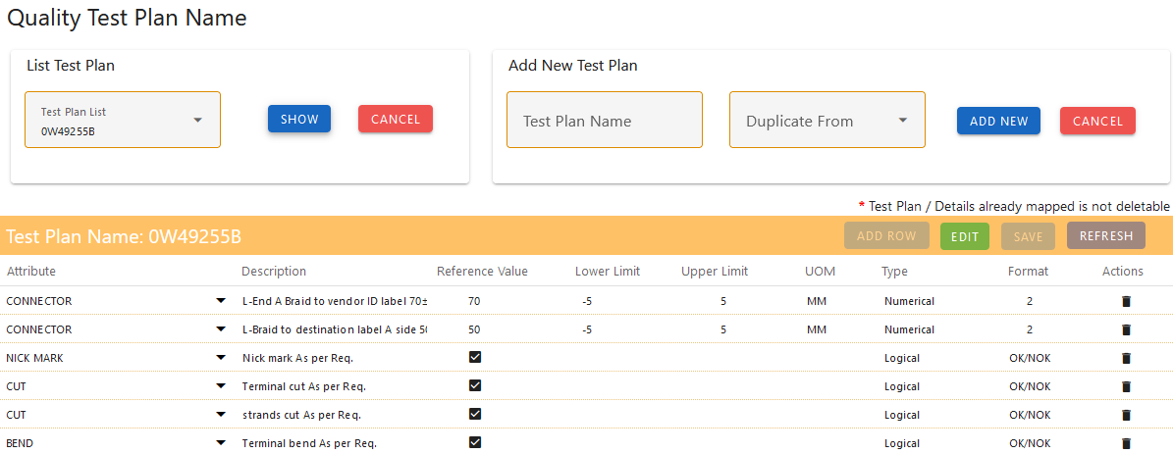

Implementation Steps

1. **Edit Mode Activation**
   * Click on the "Edit" button to enable the addition or modification of attributes.

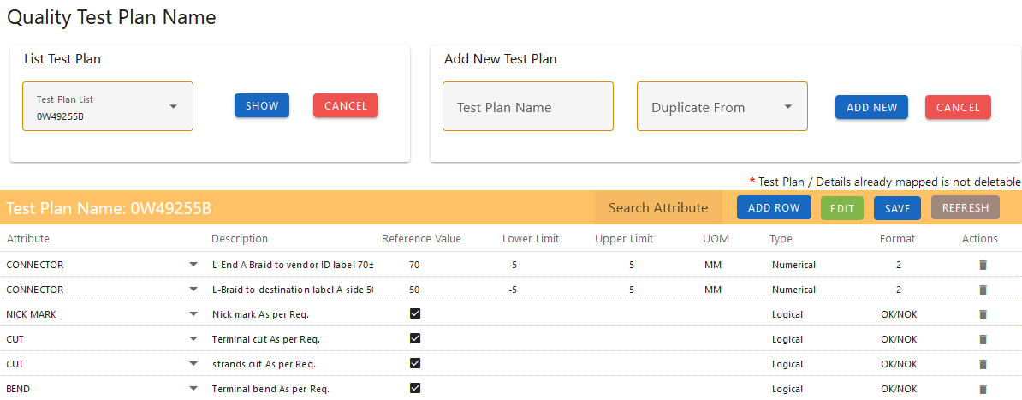

1. **Adding a New Attribute**
   * Click on the "Add Row" button to add a new quality attribute.
   * **Select Attribute:** Choose from the dropdown list.
   * **Description:** Enter a brief explanation in the text field.
   * **Reference Value:**
     + For numerical attributes, input the value in the text field.
     + For logical attributes, check or uncheck the checkbox.
   * **Upper Limit:** Input the maximum allowable value in the text field (for numerical attributes).
   * **Lower Limit:** Input the minimum allowable value in the text field (for numerical attributes).

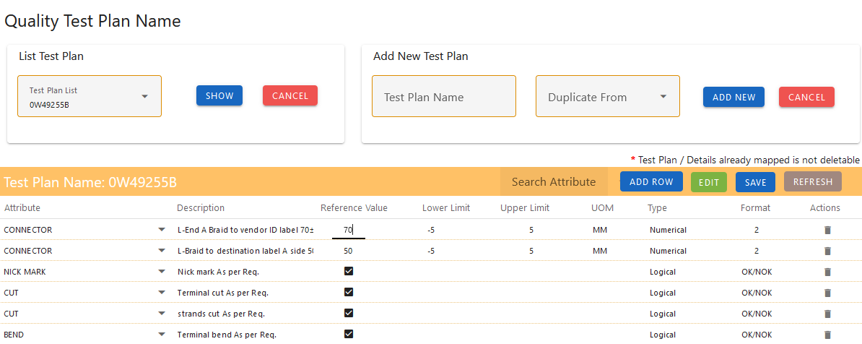

1. **Deleting an Existing Attribute**
   * Locate the attribute you wish to delete.
   * Click the delete button () last to the attribute row.
   * Confirm the deletion by a confirmation dialog.

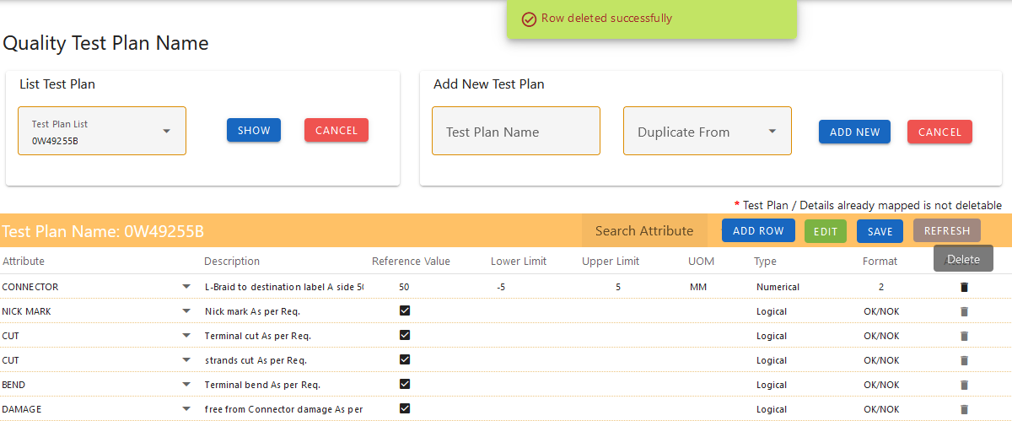

1. **Saving Changes**
   * After editing or adding attributes, ensure changes are saved by clicking the "Save" or equivalent button.
2. **Search Attribute**
   * In the toolbar, search attribute can be used to search the attribute from the list and perform the actions for the specific attribute.

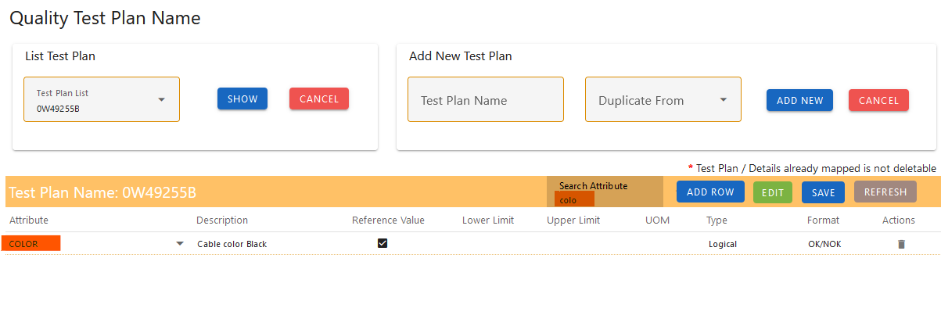

Example Fields in a Test Plan

* **Quality Attribute:** Circumference
* **Description:** Measures the circumference of the wire.
* **Reference Value:** 0.5mm
* **Upper Limit:** 0.01mm
* **Lower Limit:** 0.01mm
* **Quality Attribute:** Damage
* **Description:** check the package for any damage
* **Reference Value:** Checked (checkbox for logical)

## Work Order Detail Viewer

Overview

The **Work Order Detail Viewer** is a read-only interface designed to display comprehensive details about a work order and its associated operations. This view-only screen is intended for users to review and analyis information related to a specific work order without the ability to create or edit data. It provides a snapshot of the work order's attributes, operations, and any job orders scheduled or created for that work order.

Key Features

1. **Read-Only Display**
   * **Purpose:** Provides a detailed, non-editable view of work order information.
   * **Functionality:** Users can view all details related to the work order but cannot make changes.
2. **Work Order Details**
   * **Information Displayed:**
     + **Work Order Number:** Unique identifier for the work order.
     + **Item Description:** Description of the work order.
     + **Item Number:** item number of the work order.
     + **Quantity:** Total quantity of the work order.
     + **Routing Lot:** Routing lot assigned to the work order.
     + **Running Time:** Expected total run time for the work order.
     + **Setup Time:** Expected total setup time for the work order.
3. **Operation Details**
   * **Information Displayed:**
     + **Operation Number:** Unique identifier for each operation.
     + **Description:** Detailed description of each operation involved in the work order.
     + **Mile Stone Status:** status of the operation (e.g., true, false).
     + **Standard run and setup time:** run and setup times for each of the operation.
     + **Work Centre:** work centre where the operation is assigned.
4. **Job Orders**
   * **Information Displayed:**
     + **Job Order Number:** Unique identifier for job orders created for the work order.
     + **Operation Description:** operation description of each job order.
     + **Job Planned Date:** Planned date for each job order.
     + **Scheduled Dates:** Planned Start and end dates for each job order.
     + **Job Quantity:** Quantity for the job order.

* **Work order view table**  
  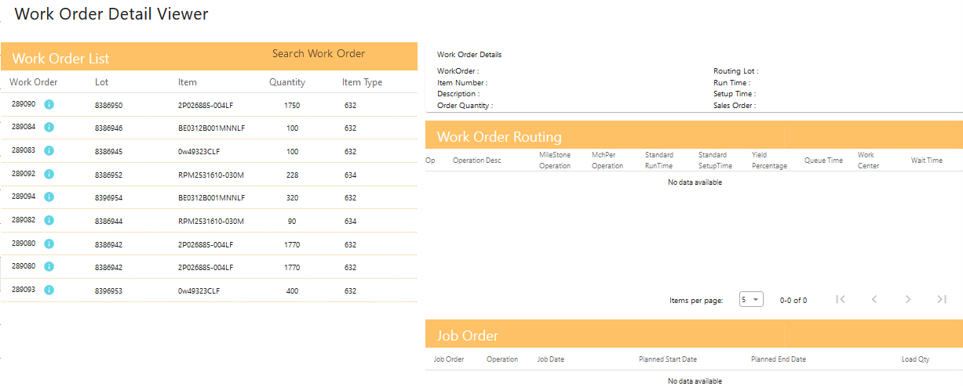
* **Work order view table with its operations and job orders created.**

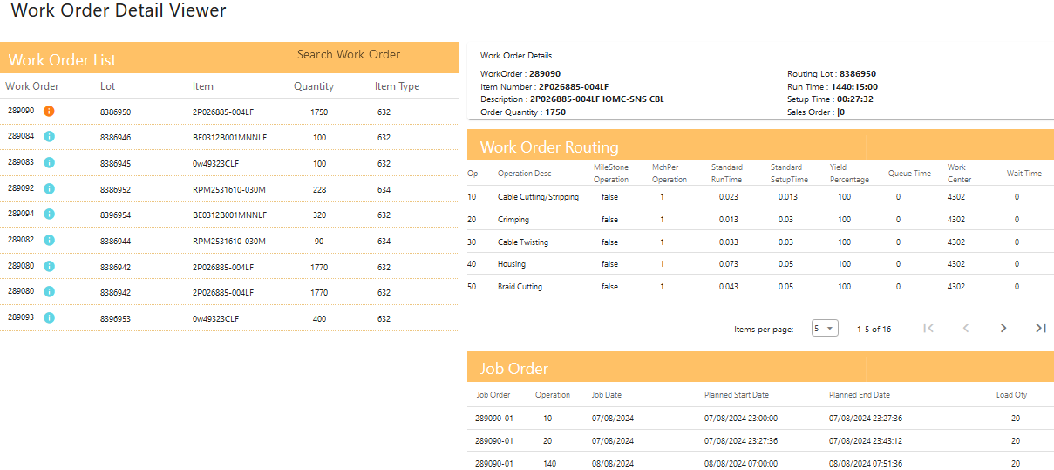

## Work order Test Plan Mapping

#### Overview

The **Work Order** **Test Plan Mapper** is designed to facilitate the mapping of work orders to test plans. It involves selecting a work order and test plan from dropdown lists, then mapping test plan descriptions to work order operations. The feature includes a status display for each description and an option to clone mappings from recent work orders with the same item.

* Initial Screen

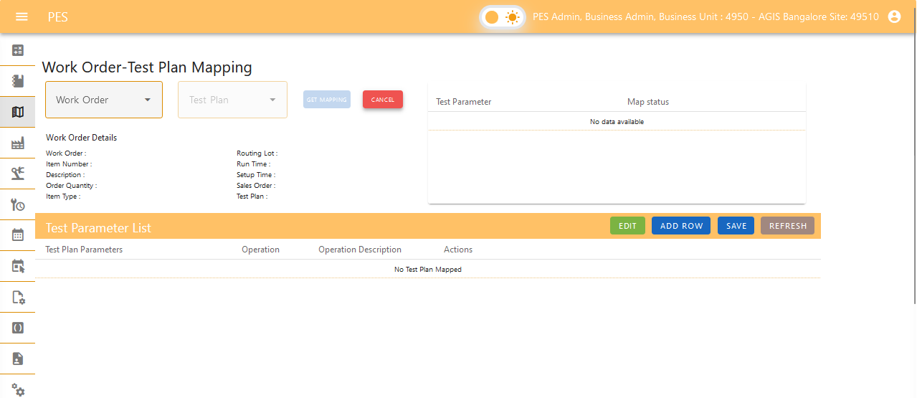

#### Functional Components

1. **Work Order Dropdown**
   * **Field Type:** Dropdown list
   * **Purpose:** Allows users to select a specific work order.
   * **Options:** List of available work orders.
2. **Test Plan Dropdown**
   * **Field Type:** Dropdown list
   * **Purpose:** Allows users to select a specific test plan.
   * **Options:** List of available test plans.
3. **Get Mapping Button**
   * **Field Type:** Button
   * **Purpose:** Fetches and displays all test plan descriptions and the operations involved in the selected work order.
4. **Test Plan Description and Operation Mapping**
   * **Field Type:** Dropdown list (for operations)
   * **Purpose:** Allows users to map each test plan description to an operation from the selected work order.
   * **Editable:** Only operations can be selected; descriptions are read-only.
5. **Mapping Status Display**
   * **Field Type:** Status indicator or message
   * **Purpose:** Shows the current status of each test plan description (e.g., whether it is correctly mapped or if any mappings are missing).
6. **Clone Mapping Option**
   * **Field Type:** Button
   * **Purpose:** Allows users to clone mappings from a recent work order with the same item.
   * **Action:** Clicking the clone button duplicates the recent mapping setup, which can then be adjusted if needed.

#### Implementation Steps

1. **Select Work Order** 
   * **Action:** Use the dropdown lists to select the desired work order and Click the  "Get Mapping" button.
   * **Result:** If no cloning possible is there Test plan dropdown will be released, else a confirmation pop up will be showed for cloning (Clone Recent Mapping)

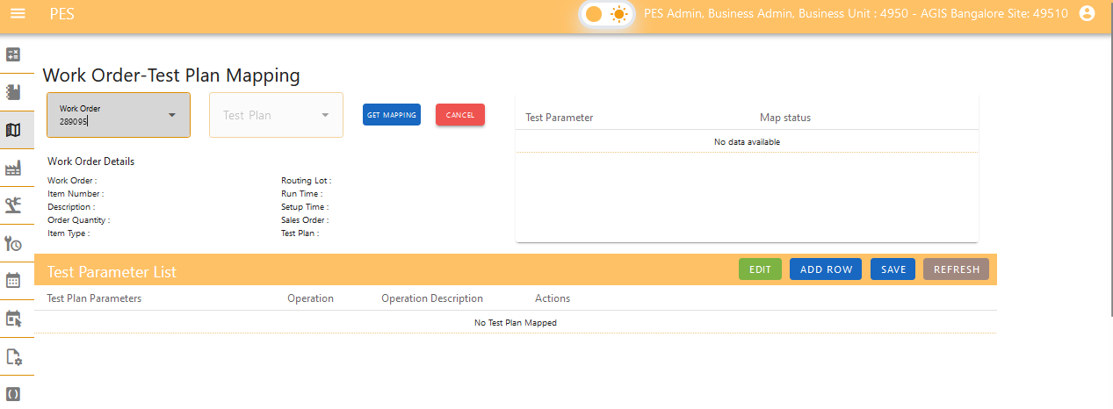

1. **Fetch Mappings**
   * **Action:** Select the test plan required from the dropdown.
   * **Result:** The system retrieves and displays all test plan descriptions for the selected test plan and the operations available for the selected work order.

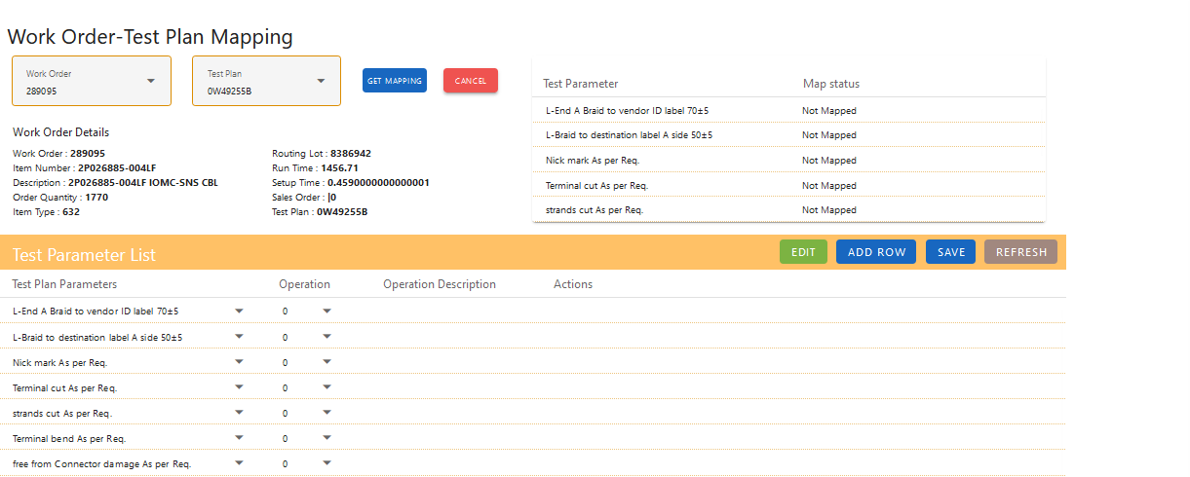

1. **Map Descriptions to Operations**
   * **Action:** For each test plan description, select an operation from the dropdown list.
   * **Requirement:** Each test plan description must be mapped to an operation. This mapping is mandatory for scheduling.

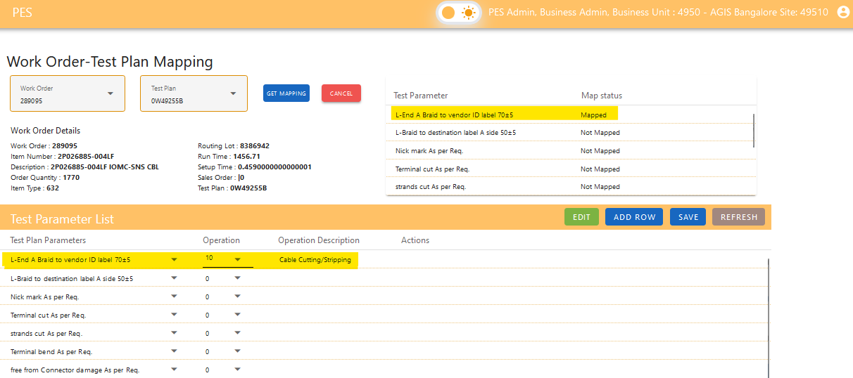

1. **View Mapping Status**
   * **Action:** The status of each description is displayed above the mapping area.

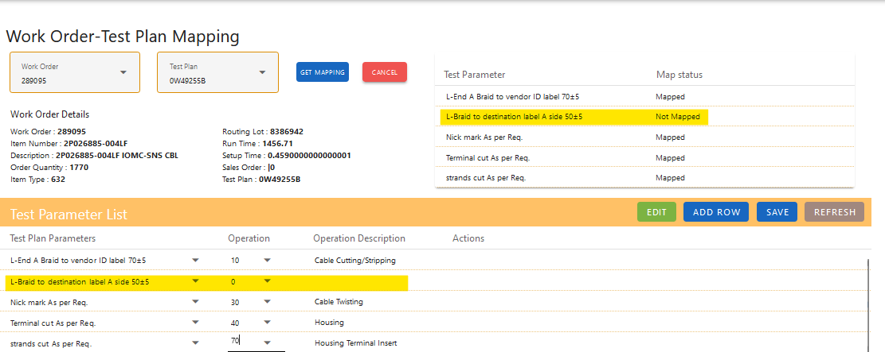

1. **Save Mappings**
   * **Action:** Ensure all mappings are complete and correct.
   * **Validation:** The system may provide feedback or require confirmation before allowing the work order to be scheduled.
   * **Status Example:** "Mapped," "Not Mapped," or any other relevant status indicator.

### Clone Recent Mapping

* + The **Clone Mapping** feature allows users to quickly replicate mappings from a recent work order with the same item. This functionality aids in streamlining the mapping process by reusing existing setups.

### Example Workflow

1. **Initiate Cloning**
   * User selects the relevant work order.
   * Clicks the "Get Mapping" button.
   * If Cloning available, it opens a confirmation dialog
2. **Confirmation Dialog**
   * A dialog box appears: “Item number “Item Number” of workorder “work order number” is previously mapped with test plan. Do you want to clone?”
   * User clicks **OK** to proceed with cloning.

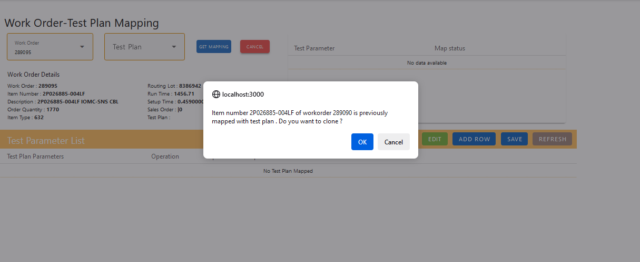

1. **View and Edit Cloned Data**
   * The system populates the mapping fields with the cloned data.
   * User reviews and, if necessary, modifies the data.

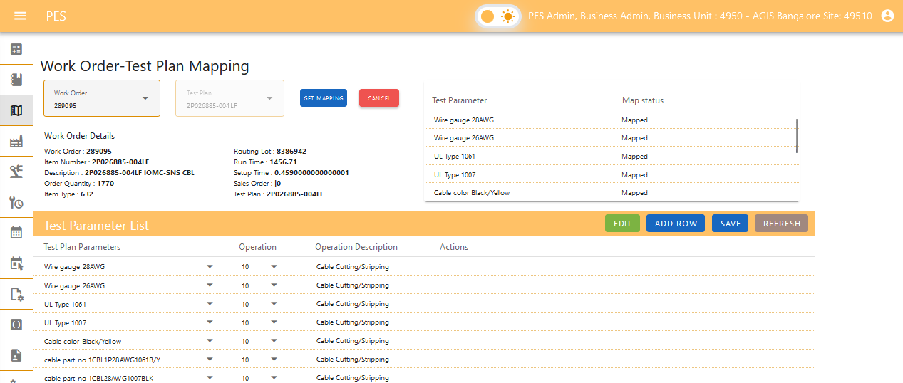

1. **Save or Adjust.**

## Holiday

The Holiday Viewer is a read-only interface designed to display the holidays recognized at a site, which are factored into scheduling processes. Users cannot edit or delete records through this view. Key features include:

* **Holiday List:** Display of all holidays observed at the site.
* **Holiday Details:** Dates and descriptions of each holiday.

This viewer provides a comprehensive overview of site holidays to assist in accurate scheduling without allowing modifications.

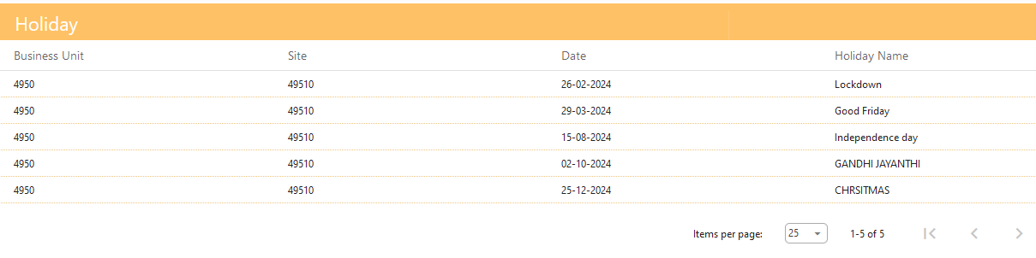

## Production Line Status

Overview

The **Production Line Status** screen provides a real-time overview of the operational status of various production lines within a manufacturing facility. This feature is designed to help managers to monitor the performance and current state of each production line, enabling timely decisions and efficient operations.

* Initial Screen

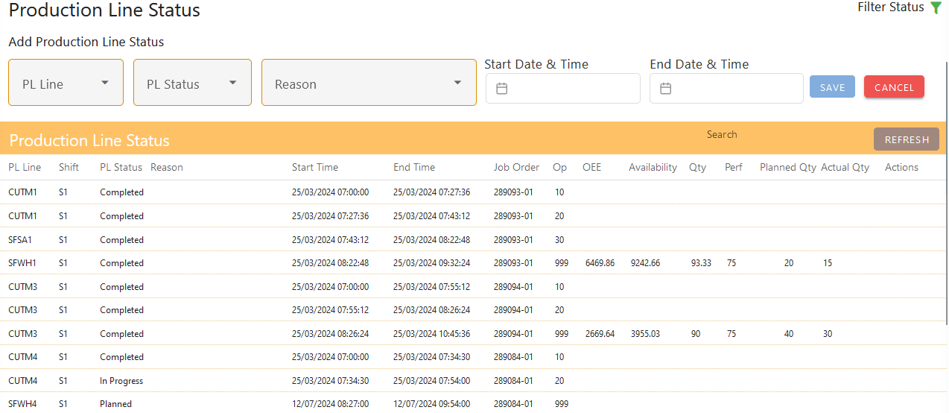

Key Features

1. **Create or Edit Production Line Status**
   * **Purpose:** Allows users to define and update the status of each production line.
   * **Statuses:**
     + **Breakdown:** Indicates that the production line is non-operational due to equipment failure or other issues.
     + **Idle:** Represents a state where the production line is operational but not currently in use.
     + **Maintenance:** Denotes that the production line is undergoing maintenance and is temporarily out of service.
     + **Planned:** Shows upcoming scheduled activities by the scheduler.
2. **Scheduling Integration**
   * **Purpose:** Prevents scheduling conflicts by considering the current status of production lines.
   * **Functionality:** The system will cross-reference scheduled jobs with the production line status to avoid overlapping with periods of Breakdown, Idle, or Maintenance.
3. **Efficiency Monitoring**
   * **Purpose:** Tracks the performance and utilization of production lines.
   * **Functionality:** Provides metrics on how often production lines are in each status, helping to identify areas for improvement and optimize production scheduling.
4. **Avoid Scheduling Conflicts**
   * **Purpose:** Ensures that new jobs or production schedules do not overlap with existing statuses.
   * **Functionality:** Alerts users if a scheduled job conflicts with a production line’s current status (e.g., scheduling a job during a Maintenance period).

Create or Edit Status

* **Creation:**
  + **Fields Required:** Select Production line, status type (Breakdown, Idle, Maintenance), reason, enter start time, end time.
  + **Save:** Confirm and save the new status.
* Entry of new record with Production Line, PL status, Reason, Start time and End time
  + Production Line: CUTM1
  + PL Status: Breakdown
  + Start Time: 20-08-2024 12:17:00
  + End Time: 20-08-2024 15:17:00

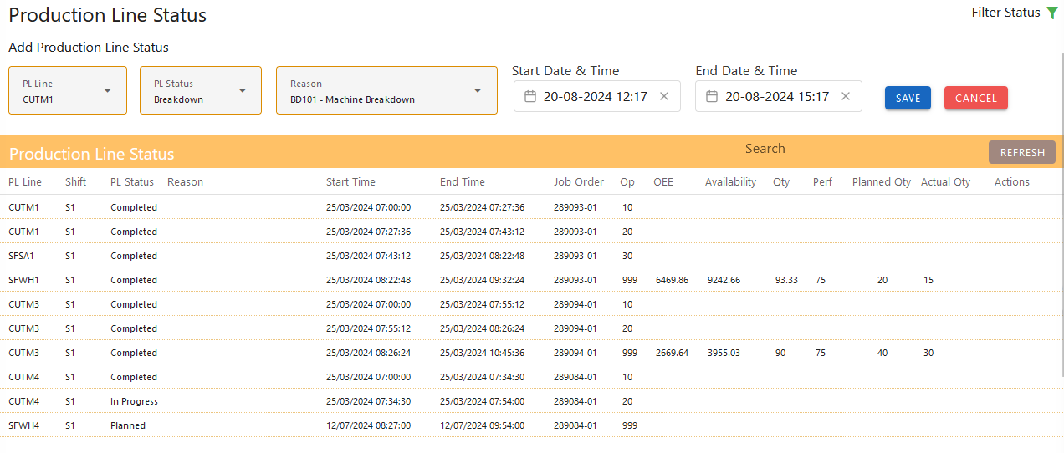

* The new record got added and got split based on shit hours (S1 – 07:00:00 to 15:00:00, S2 – 15:00:00 to 23:00:00, S3 – 23:00:00 to 07:00:00)
  + Record 1:
    - Production Line: CUTM1
    - PL Status: Breakdown
    - Start Time: 20-08-2024 12:17:00
    - End Time: 20-08-2024 15:00:00
  + Record 2:
    - Production Line: CUTM1
    - PL Status: Breakdown
    - Start Time: 20-08-2024 15:00:00
    - End Time: 20-08-2024 15:17:00

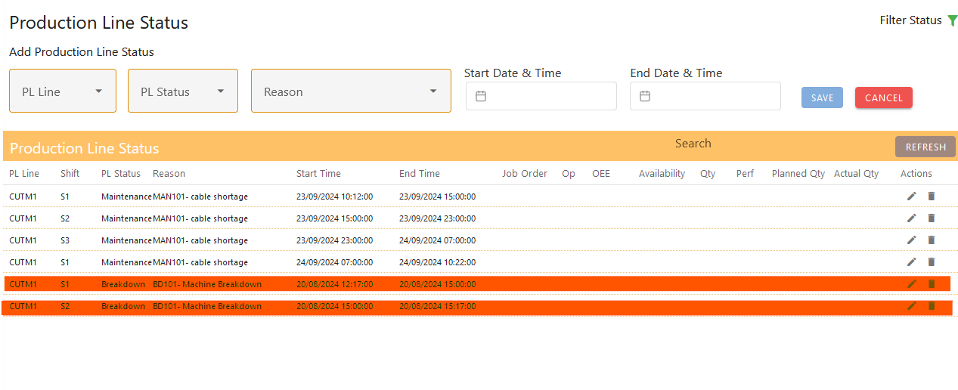

* **Editing (only for the future statuses):**
  + **Action:** Select an existing status from the list.
  + **Fields Editable:** Update status type, start time, end time, and notes.
  + **Save:** Confirm and save the changes.
* Editing the existing record
  + Production Line: CUTM1
  + PL Status: Breakdown
  + Start Time: 20-08-2024 12:17:00
  + End Time: 20-08-2024 15:00:00

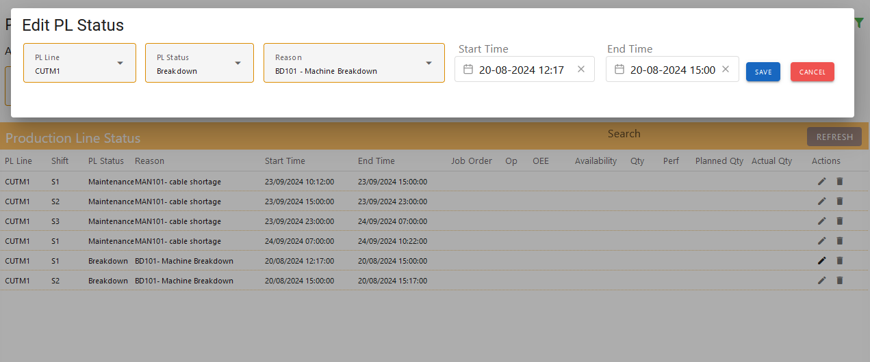

* Editing the start time of the record
  + Production Line: CUTM1
  + PL Status: Breakdown
  + **Start Time: 20-08-2024 12:00:00 (from 12:17:00)**
  + End Time: 20-08-2024 15:17:00

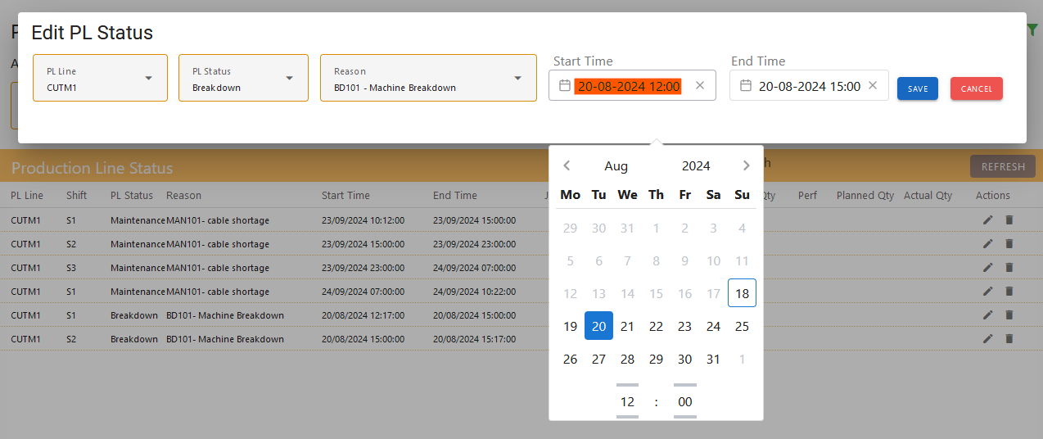

* Edit record saved
  + Production Line: CUTM1
  + PL Status: Breakdown
  + Start Time: 20-08-2024 12:00:00
  + End Time: 20-08-2024 15:17:00

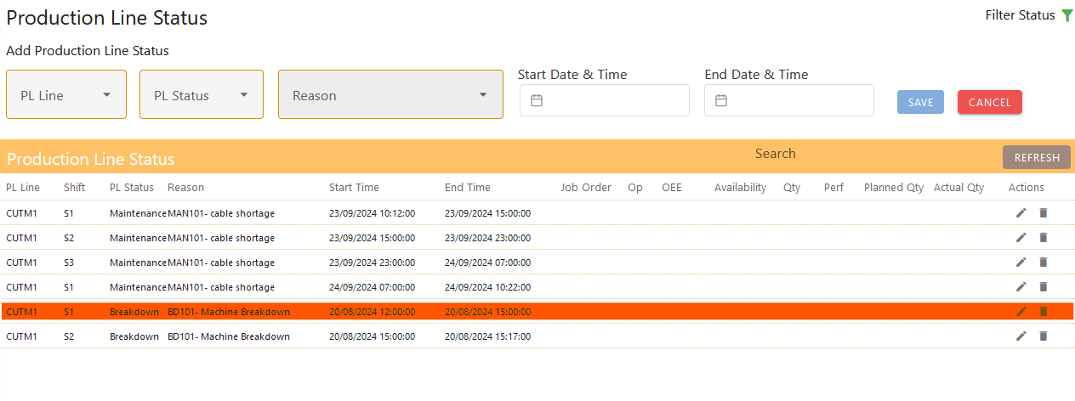

* **Delete (only for future statuses):**
  + **Action:** Select the status to be deleted. Confirm it from the dialogue box and also the data won’t be considered for upcoming scheduling.
  + **Selecting the record for deletion**
    - Production Line: CUTM1
    - PL Status: Breakdown
    - Start Time: 20-08-2024 15:00:00
    - End Time: 20-08-2024 15:17:00

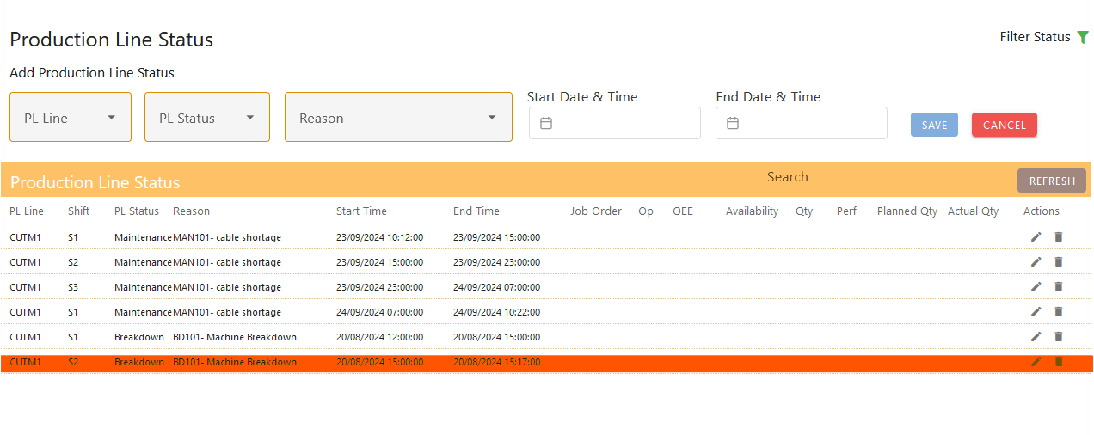

* **Confirmation before deleting the record.**

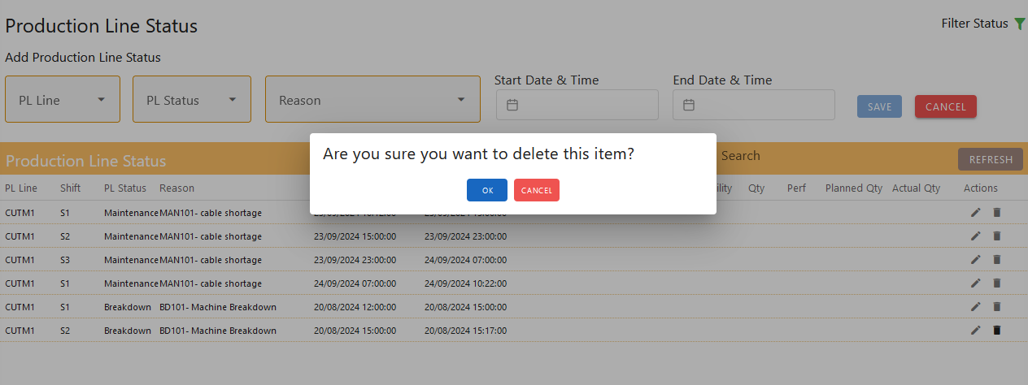

* **Record got deleted.**
  + Production Line: CUTM1
  + PL Status: Breakdown
  + Start Time: 20-08-2024 15:00:00
  + End Time: 20-08-2024 15:17:00

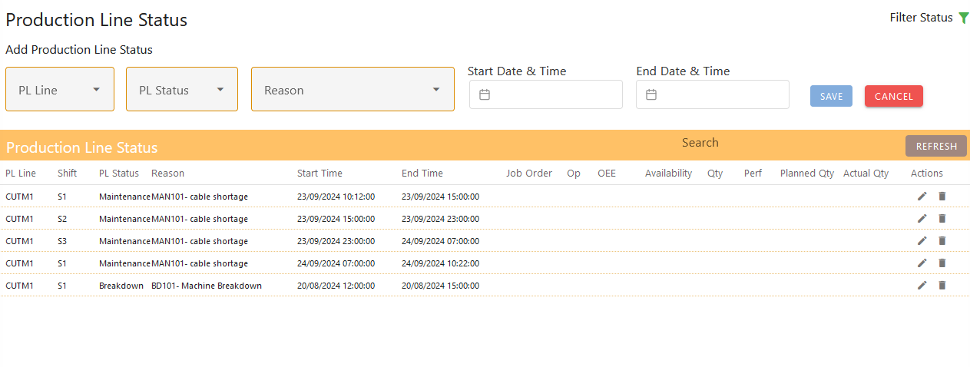

**Shift-Based Data Storage**

* + **Description:** Data is stored based on shifts, where each shift represents an 8-hour period.
  + **Example:** If a production line status of "Maintenance" is recorded from 22/03/2024 07:00:00 to 23/03/2024 07:00:00 (24 hours), this period will be automatically divided into three shifts:
    - **Shift 1 (S1):** 22/03/2024 07:00:00 to 22/03/2024 15:00:00
    - **Shift 2 (S2):** 22/03/2024 15:00:00 to 22/03/2024 23:00:00
    - **Shift 3 (S3):** 22/03/2024 23:00:00 to 23/03/2024 07:00:00

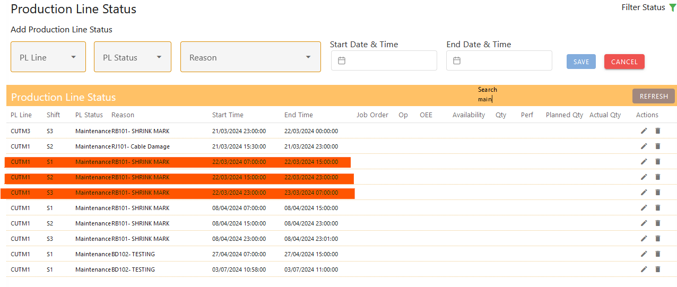

Other Features

* **Filtering by Date Range:**
* **Purpose:** Allows users to view statuses within a specific date range, improving the ability to manage and analyze data for particular periods.
* **Steps:**
  + Click on  filter icon on top right.
  + Select start and end dates, apply filter, view results.

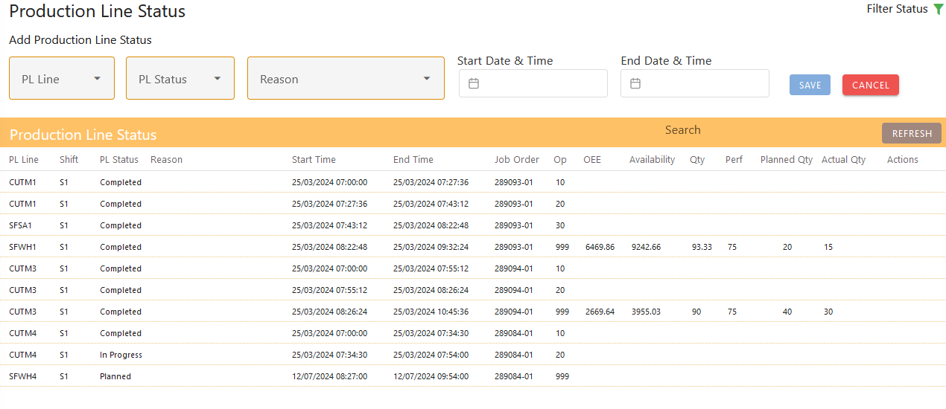

* Selection of Start and End time
  + Start Time: 01-08-2024 12:08:00
  + End Time: 31-08-2024 12:08:00

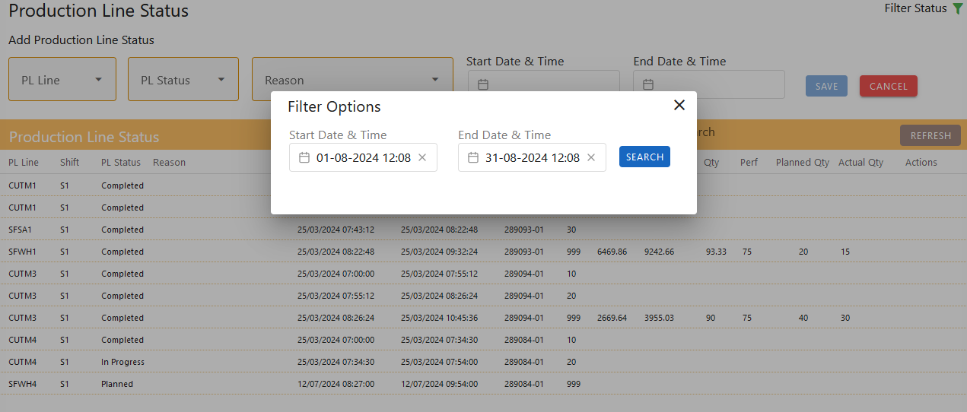

* Records available for the Selected Dates
  + First Page

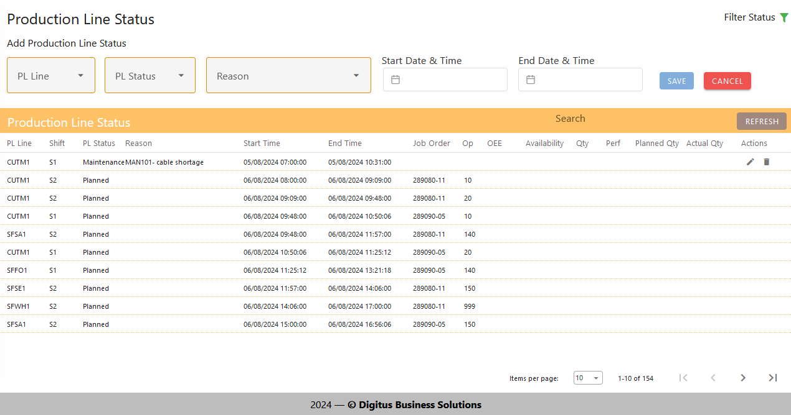

* Last page

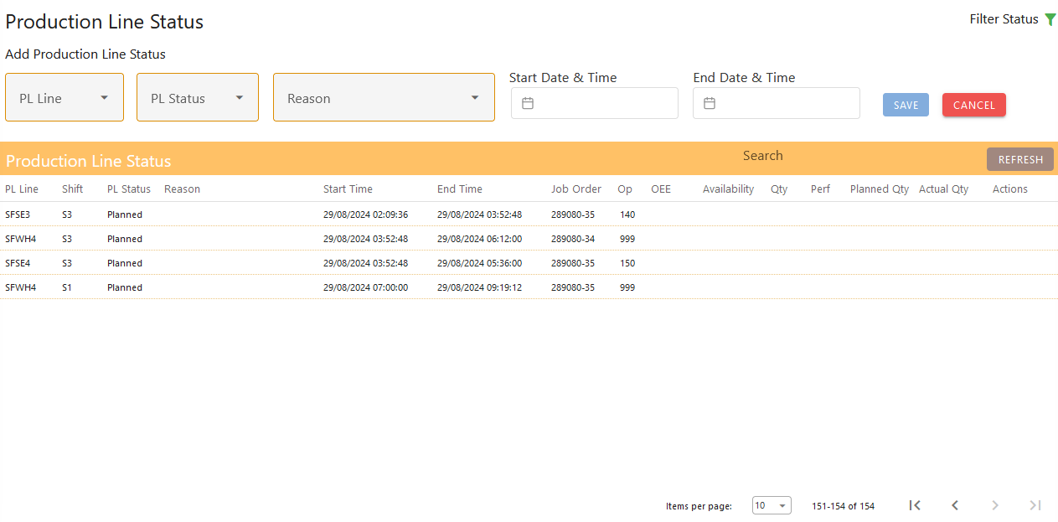

* **Search Across Data:**
* **Purpose:** Enables users to quickly locate specific statuses based on various criteria such as status type, production line, or reason.
* **Steps:** Enter search like production line, status, start or end time and view results.

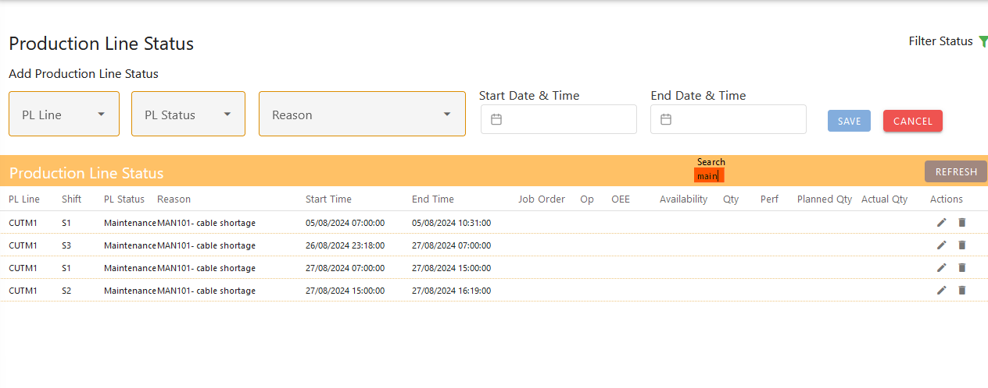

## Scheduling Work Bench

Overview

The Scheduling Work Bench is designed to efficiently manage work orders, including splitting large quantities into smaller job orders, editing schedules, and providing comprehensive views of production line statuses. This tool enhances scheduling accuracy and resource management by offering real-time insights and graphical representations of production schedules.

* Initial Page

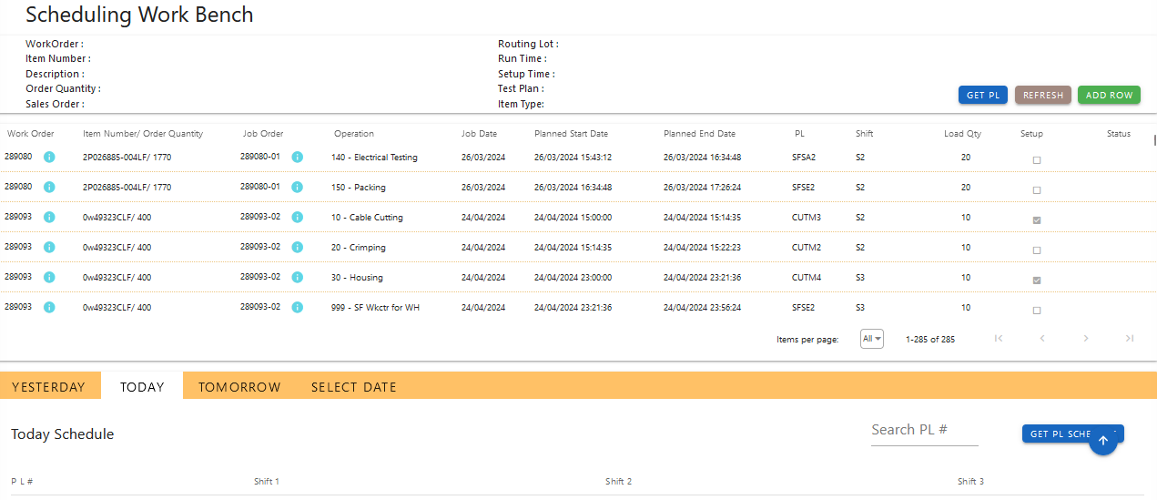

* Scroll Down for Production Line Status Graphical Chart View

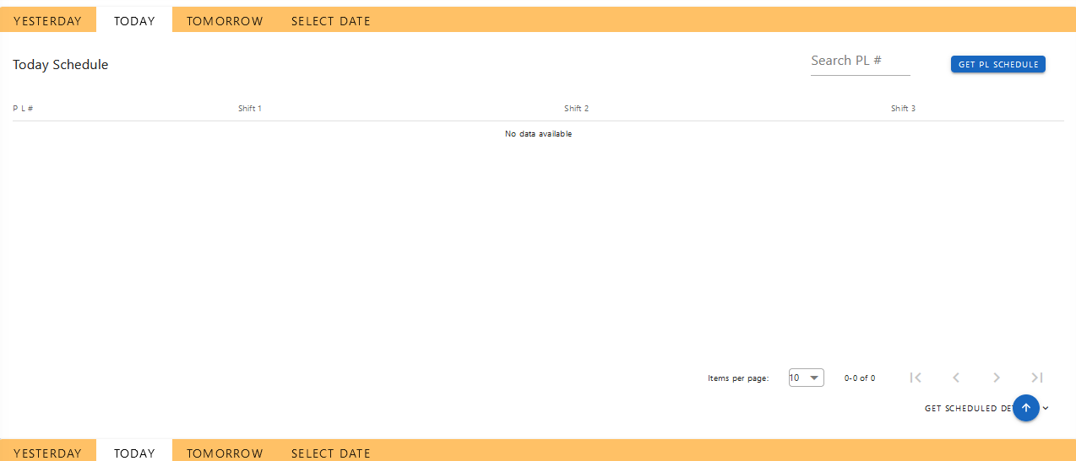

* Scroll Down for PL Status Graph View

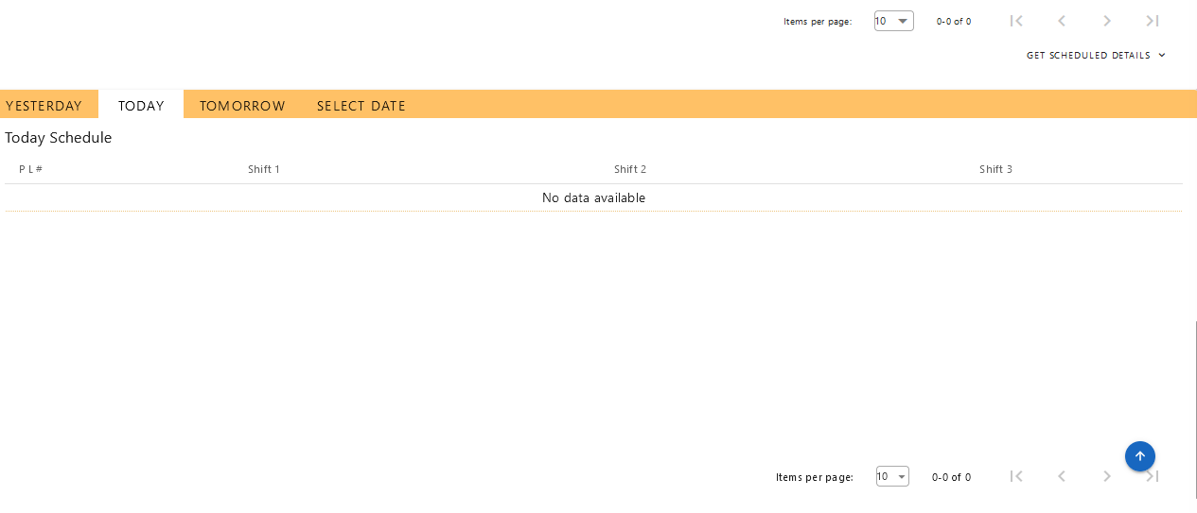

Key Features

1. **Bulk Quantity Splitting**:

* **Work Order Management**: Start with a bulk work order, e.g., 1000 units.
* **Job Order Creation**: Divide the bulk quantity into smaller, manageable job orders. For example, split 1000 units into multiple job orders of 100 units each or other specified quantities.
* **Custom Splits**: Configure varying quantities for each job order as needed to match production requirements and line capacities.

1. **Operation Assignment**:

* Allocate each split job order to specific production lines.
* Assign shifts and dates for each job order based on operational availability and scheduling requirements.

1. **Validation Process**:

* Use the "Validate" button to ensure that each split job order is feasible and that resources are available.
* The system checks if the production line, shift, and date are clear of conflicts and if the schedule adheres to all constraints.
* Positive validation allows you to save the job orders; negative validation provides error messages for required adjustments.
* Save the validated job orders.

1. **Edit Schedule Functionality**:

* **Editable Job Orders**: If a job order has not yet started, you can edit its details, including production line, shift, and date.
* **Revalidation**: After making changes to the job order, revalidate the schedule to ensure all adjustments are compatible and conflicts are resolved.
* **Update and Save**: Apply changes and save the updated job order schedule once revalidation is successful.

1. **Error Handling and Revalidation**:

* Address any validation issues by modifying the production line, shift, or date as suggested by the system.
* Revalidate after adjustments to ensure all conditions are satisfied.
* Continue this process until all job orders are successfully validated and saved.

6. **Production Line Status Viewing**:

* **Status Screen Access**: View the status of production line directly from the Scheduling Work Bench.
* **Scheduling Based on Status**: Make informed scheduling decisions based on the current status of production lines to avoid conflicts and optimize resource utilization.
* All actions involved in production line status can be done from the pop up screen.
* Click on  Get Pl button to see the PL records.

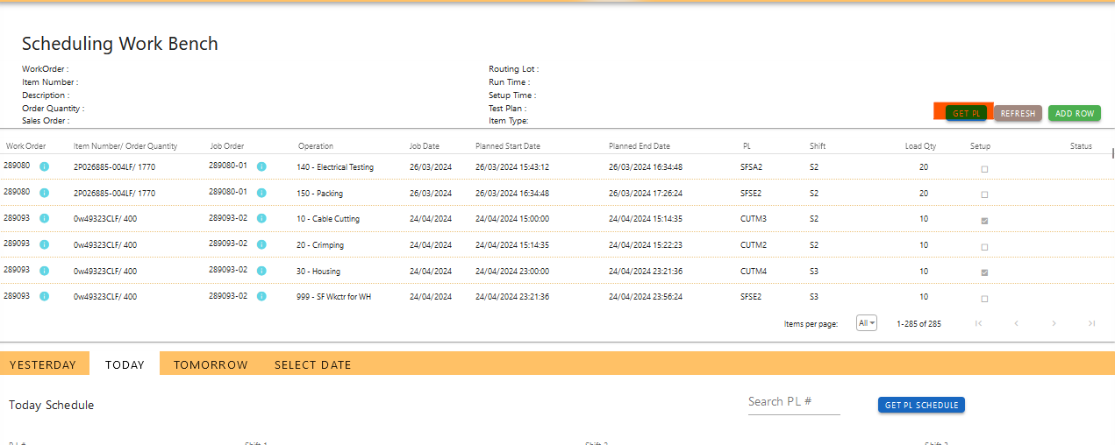

* Production Line Status screen will be opened as a pop up.

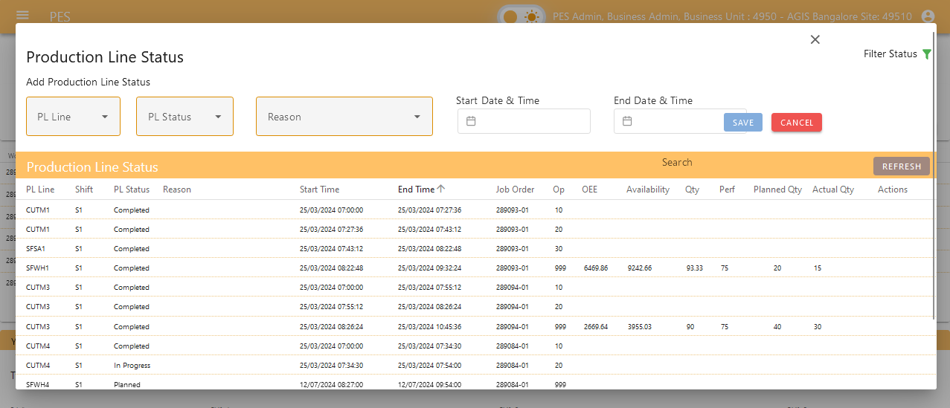

Workflow to schedule a job order

1. **Add New Schedule Entry**:
   * Click the  "Add Row" button to create a new job order entry in the scheduling workbench.

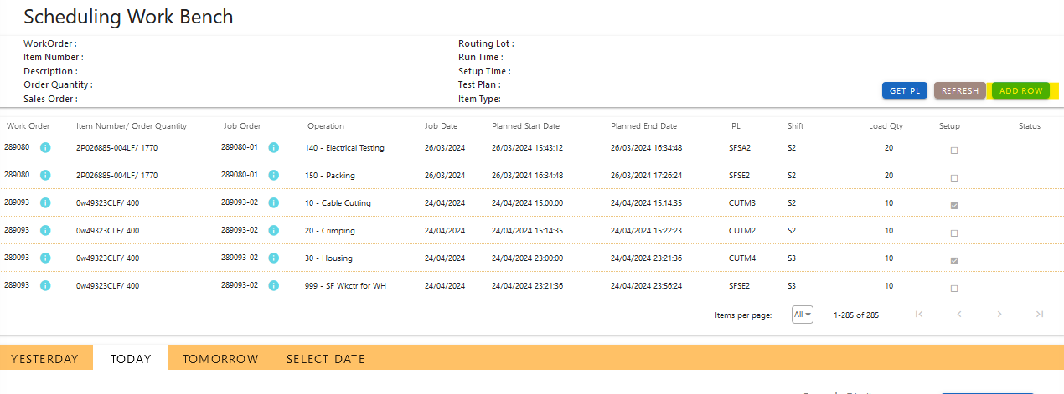

* New Pop up screen will be opened as below.

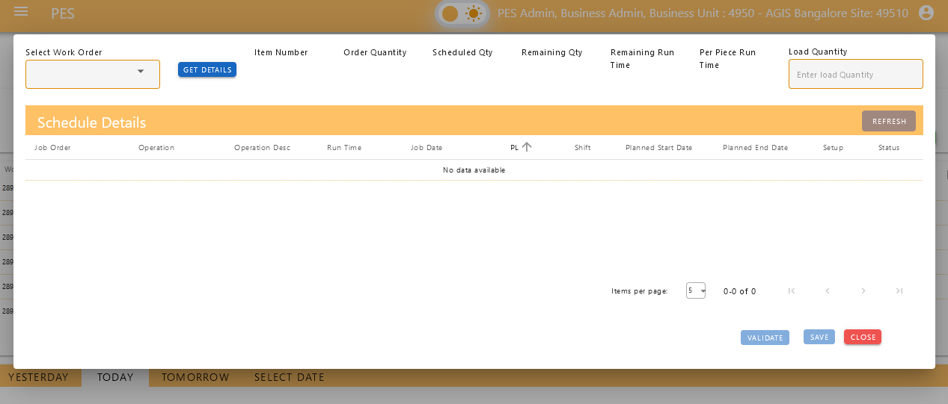

1. **Select Work Order**:
   * Click the dropdown menu in the "Work Order" field.
   * Choose the work order you want to schedule and click on  Get Details button. This action will automatically populate the mapped operations and their details from the backend.

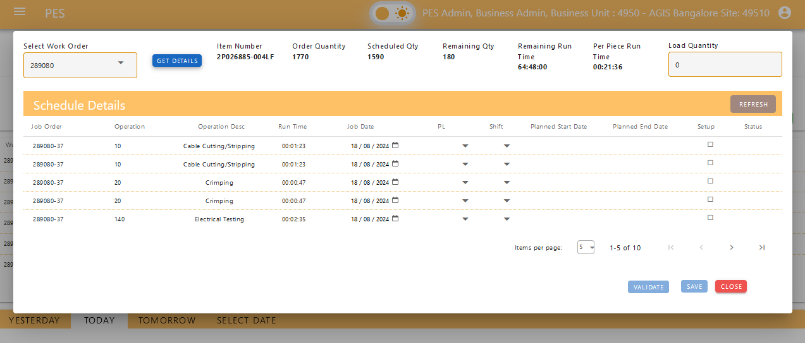

1. **Define Job Order Details**:
   * **Quantity (Qty)**: Enter the quantity for the job order.
   * **Production Line (PL)**: Select the production line where the job order will be executed.
   * **Shift**: Specify the shift during which the job order will take place.
   * **Date**: Set the date for each operation associated with the job order.

* Selection of job date & Enter the load quantity

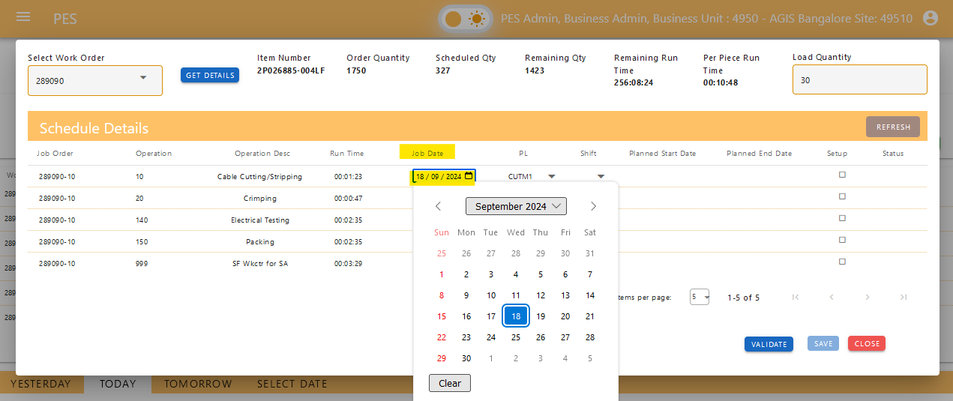

* Selection of production line

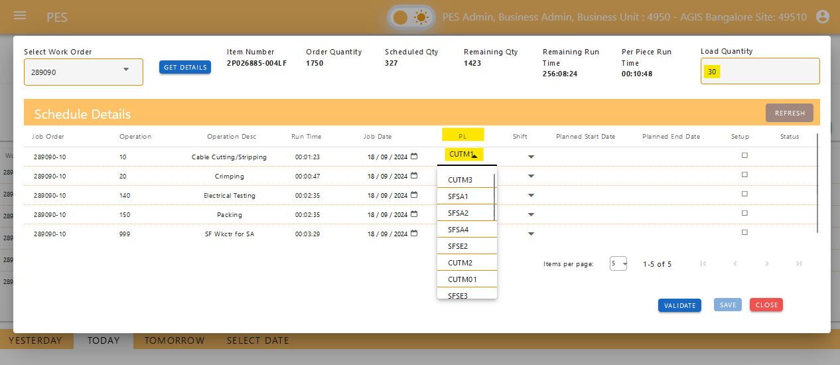

* Selection of Shift

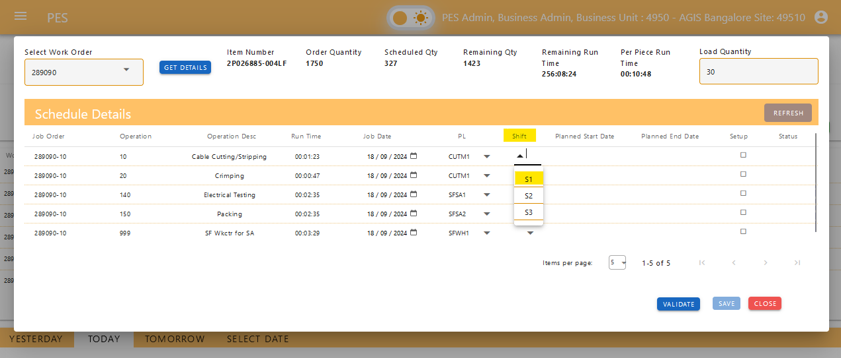

1. **Validate Schedule**:
   * Click the "Validate" button to check if the schedule is feasible.
   * **Planned Dates**: After validation, the system will display the planned start and end dates for the job order.
   * **Status Check**: Review the validation status to determine if all scheduling conditions are met or if there are any errors.

Types of Validation messages while validate

* Message to move the operation to next Shift

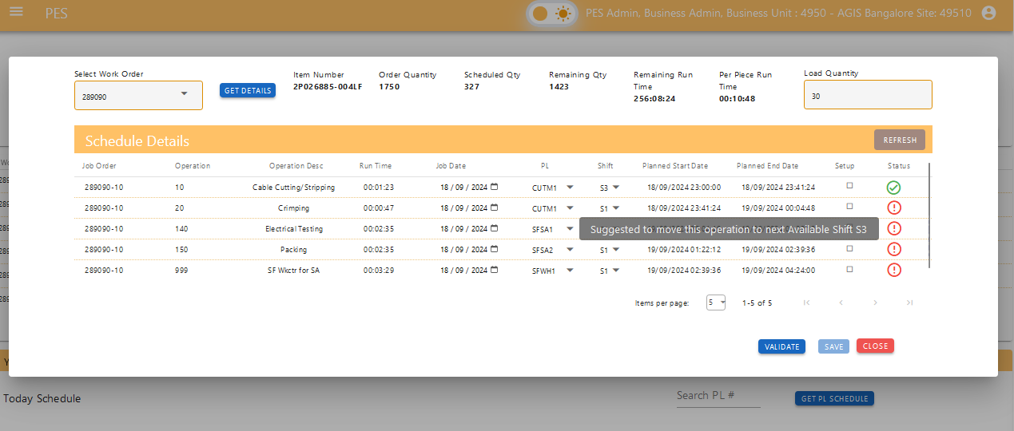

* Message to move the job for next day

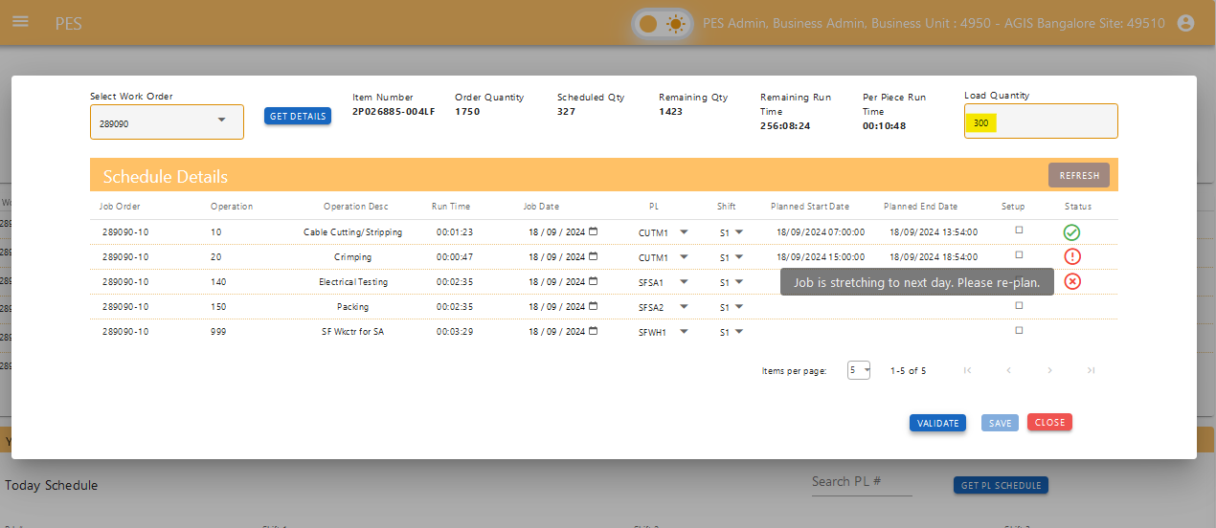

* Message that job scheduled on Holiday

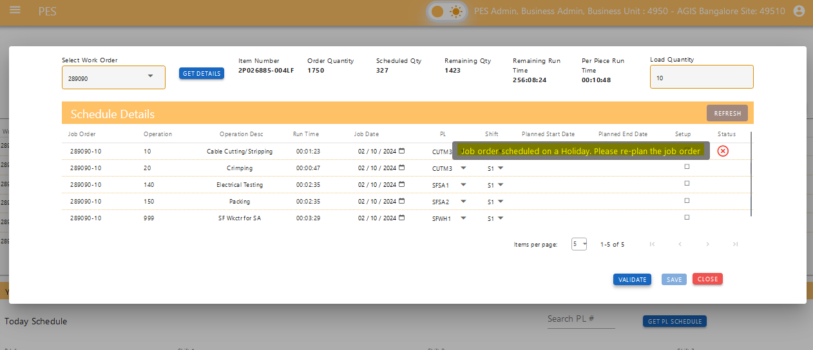

* Message that validation is successful.

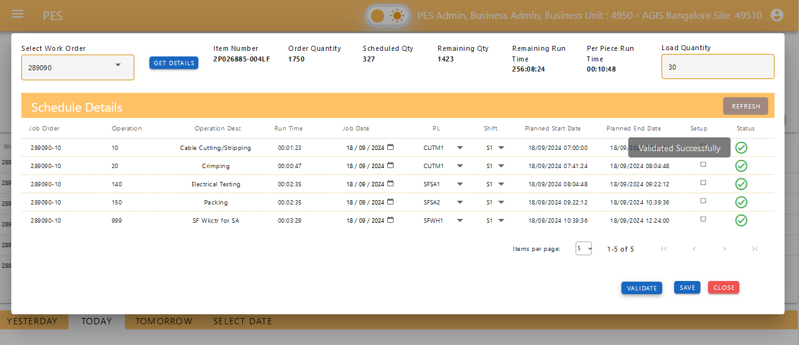

1. **Error Handling**:
   * If validation reveals errors:
     + **View Error Messages**: Examine the error messages provided by the system, which will indicate what needs to be adjusted (e.g., production line, shift, date).
     + **Modify Details**: Adjust the production line, shift, or date based on the error messages.
     + **Revalidate**: Click "Validate" again after making changes to ensure that the new details resolve the issues.
     + **Repeat**: Continue adjusting and revalidating until all errors are resolved and the schedule is validated successfully.
2. **Save Schedule**:
   * Once validation is complete and no errors are present, check for the planned start and planned end date for all operation then save the job order schedule to finalize the entry.

This workflow ensures that job orders are accurately scheduled, taking into account the availability of production lines, shifts, and dates, while also providing mechanisms to handle and correct errors.

Production Line Status Graphical View

* **Graphical Representation**: Access a graphical view that displays job and production line statuses based on shifts and selected dates.
* **Normal View**: View a standard layout of job and production line statuses for a straightforward overview.
* **Search Functionality**: Utilize search features to find specific job orders, production lines, or dates efficiently.
* Initially for both the production line graph will show the data of current day and can select the previous day and next day

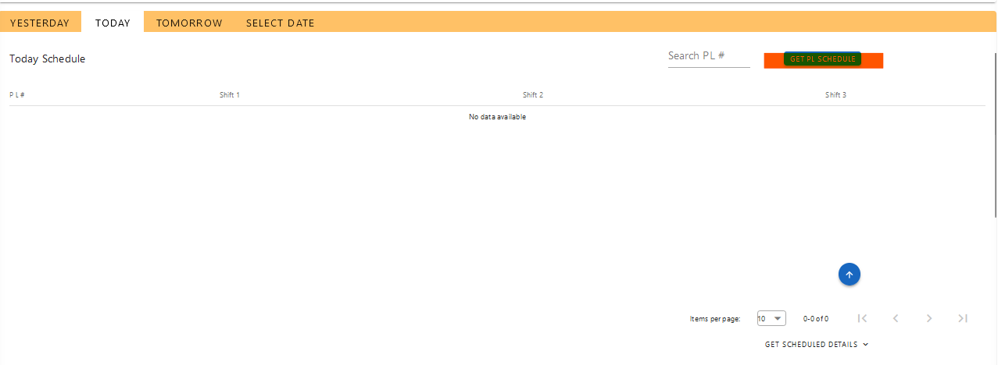

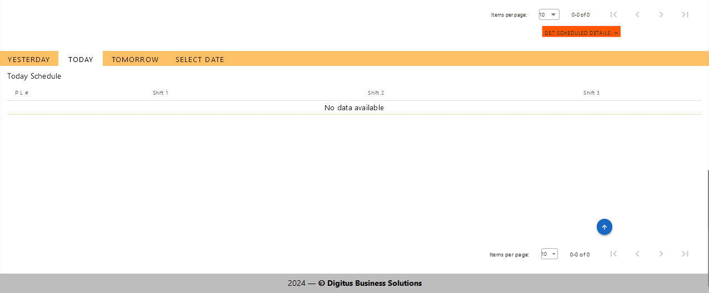

* Also, if wanted to select the custom date click on  “Select Date” and select the required date.

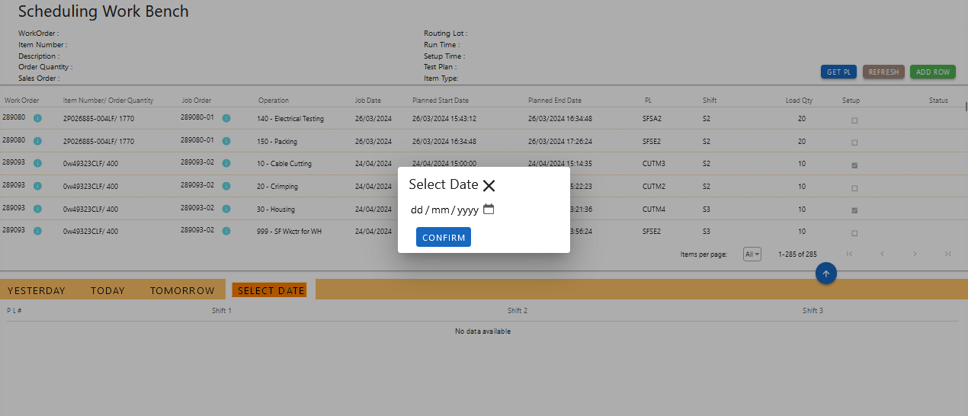

* Selecting the custom date to view data.
  + Selected Date: 19/08/2024

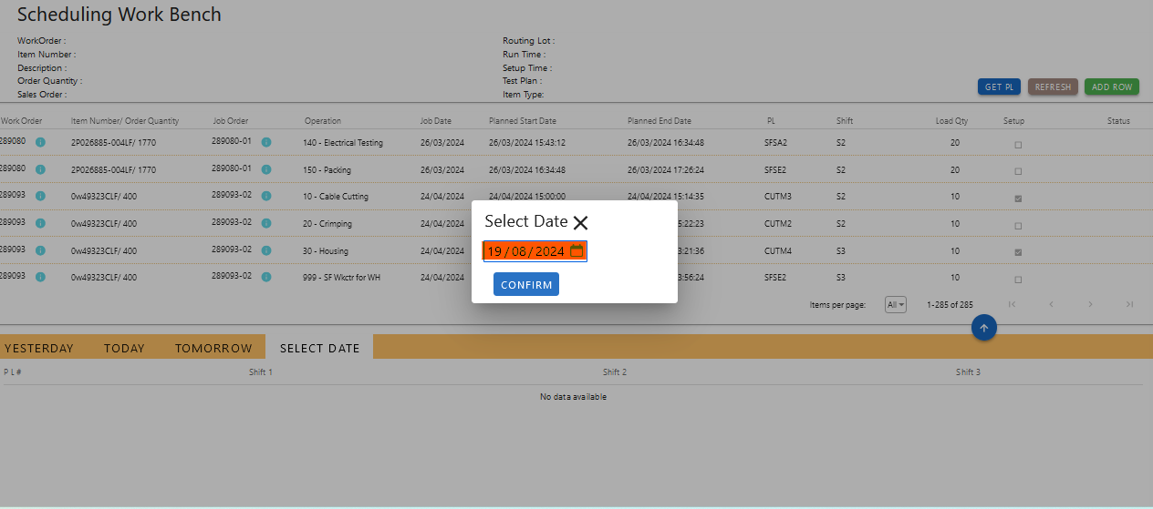

* Data shown for the selected with all the Production Line and its status in graphical view.

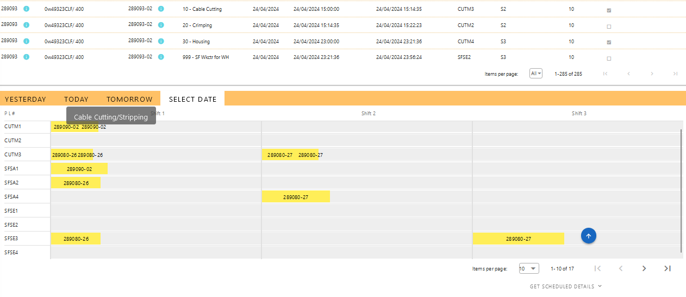

* Data shown for the selected with all the Production Line and its status in table view.

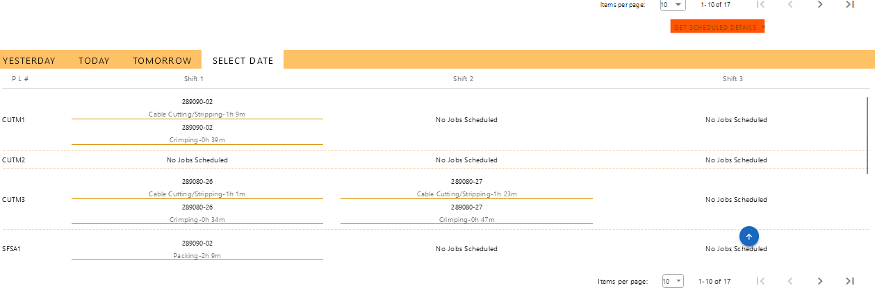

# 17. Job Travel Card (JTC Report)

The Job Travel Card (JTC) Report is a tool for generating and viewing detailed reports on completed job orders. Users can filter and retrieve reports based on three different criteria, with the ability to preview and download the results in PDF format.

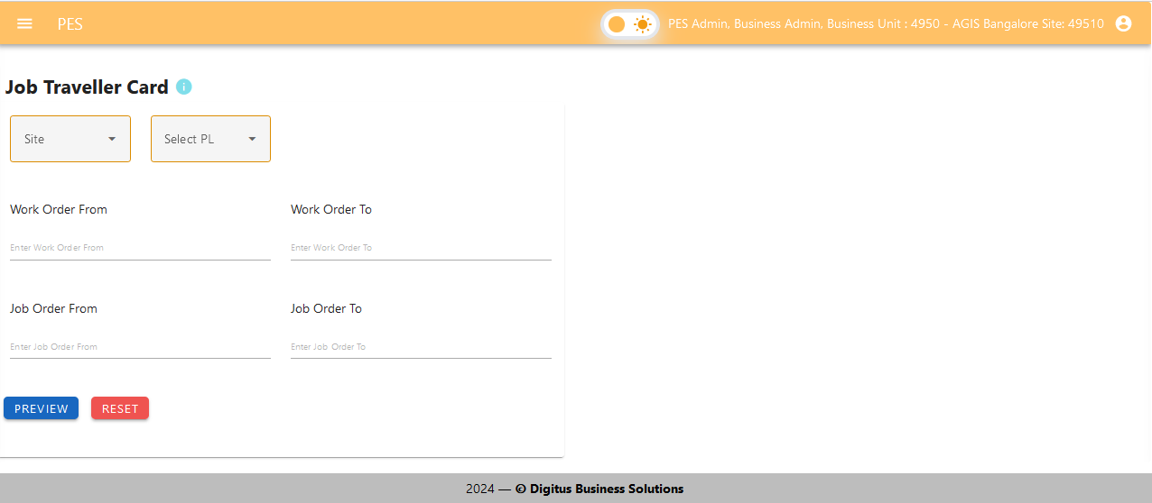

Key Features

1. **Report Criteria**:
   * **Site, Production Line, From Date, To Date**:
     + Generate a report by specifying the site, production line, and a date range (from and to dates).
   * **Between From and To Work Orders**:
     + Retrieve job order details for a range of work orders, from a specified start work order to an end work order.
   * **Between From and To Job Orders**:
     + Obtain job order information for a range of job orders, from a specified start job order to an end job order.
2. **Report Generation**:
   * **Selection and Preview**:
     + Based on the selected criteria (one of the three combinations), the system will display a preview of the completed job orders report on the right side of the interface.
   * **PDF Download**:
     + Users can download the displayed report as a PDF file for offline review and record-keeping.

Workflow

* **Select Report Criteria**:
  + Choose one of the following options to filter the report:
    - **Site, Production Line, From Date, To Date**: Enter the site, production line, and date range.
    - **Between From and To Work Orders**: Enter the start and end work orders.
    - **Between From and To Job Orders**: Enter the start and end job orders.
* Selection on Site, production line, from date and to date.

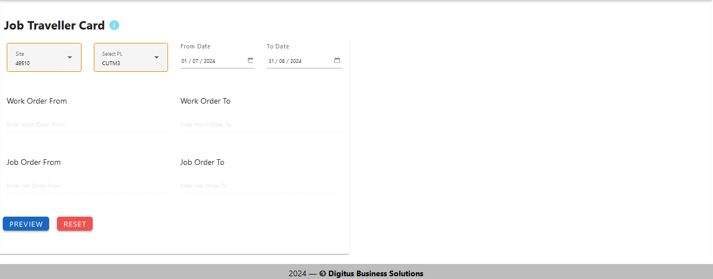

* Preview for the selection on Site, production line, from date and to date.

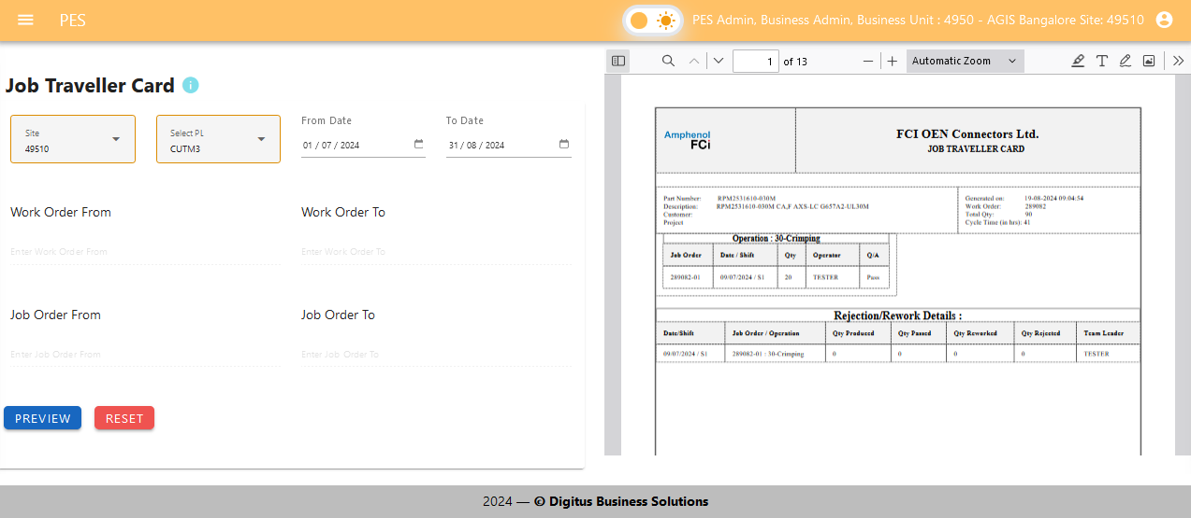

* Selection for between work orders.

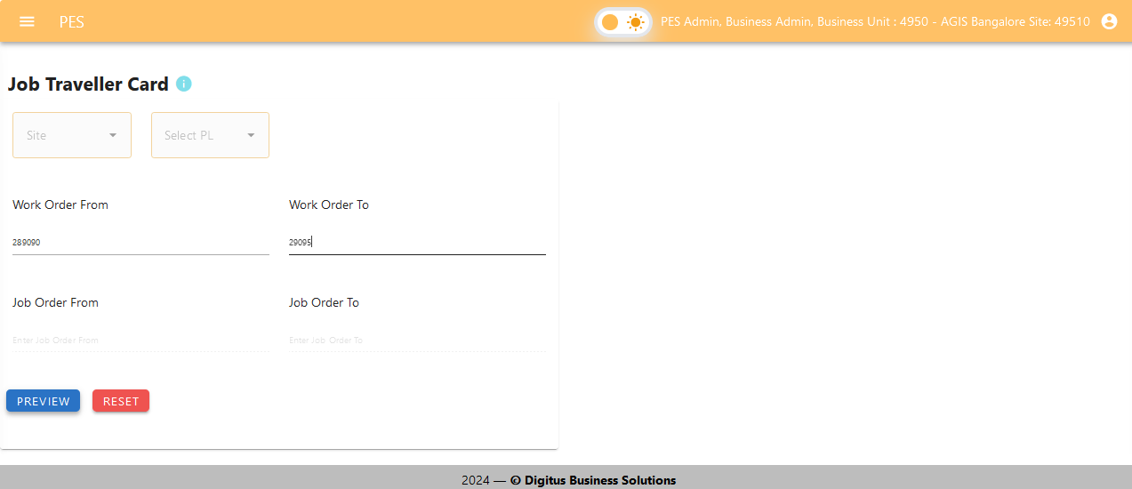

* Preview for the selection for between work orders.

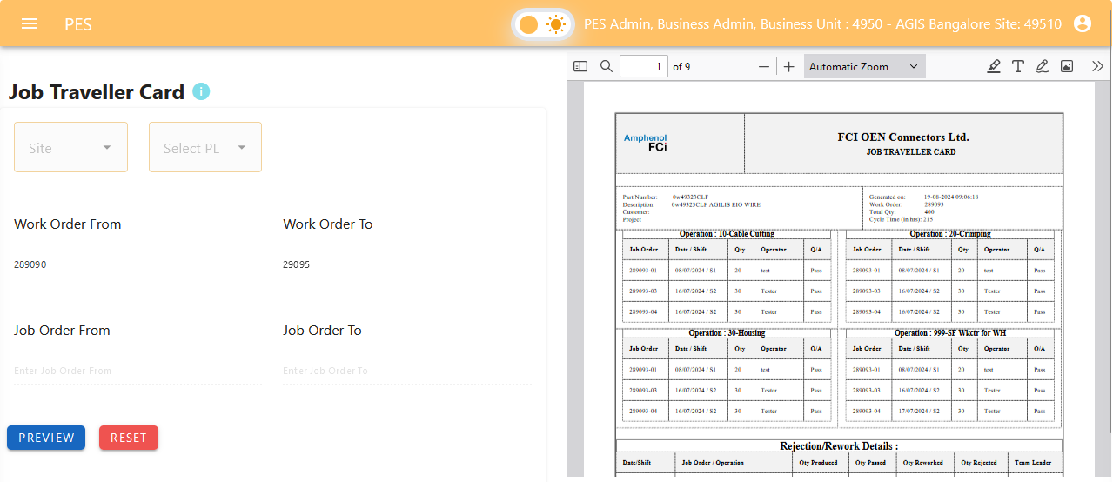

* Selection for between job orders.

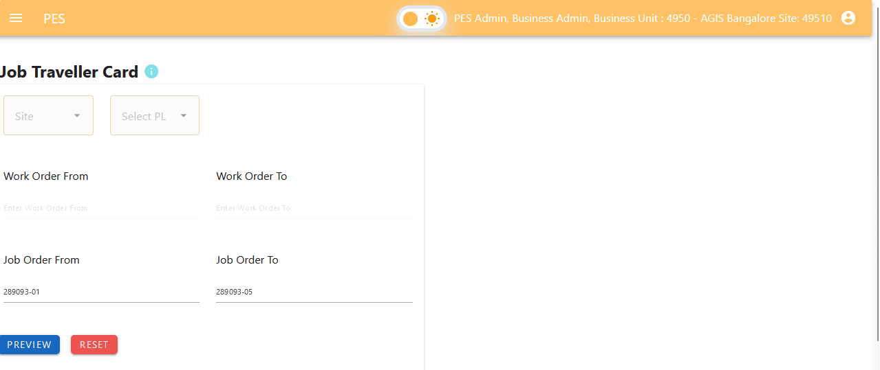

* Preview for the Selection for between job orders.

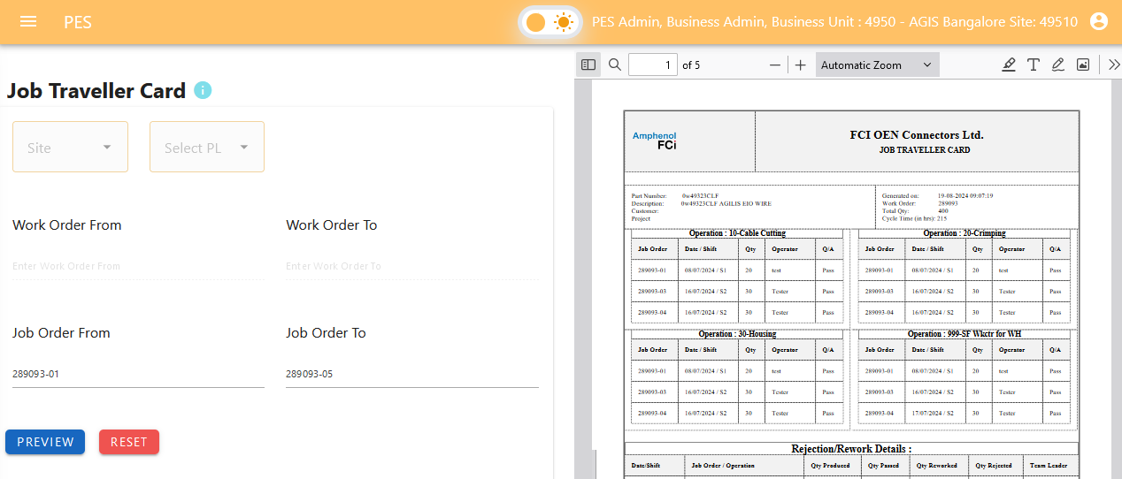

* **Generate Report**:
  + After selecting the criteria, the system will compile the relevant data.
  + The report preview will appear on the right side of the interface, reflecting the completed job orders based on the selected filters.
* **Preview and Download**:
  + Review the report preview to ensure it meets the desired criteria.
  + Click the download button to save the report as a PDF file.

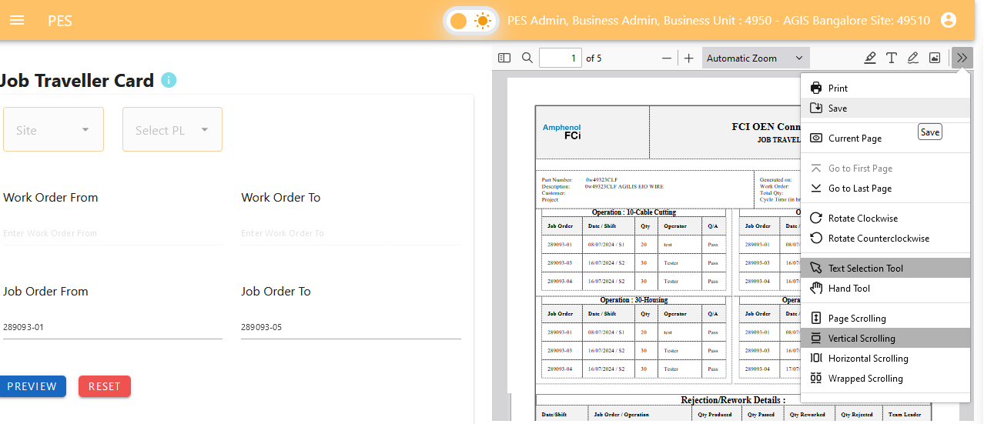

Benefits

* **Comprehensive Analysis**: Obtain detailed reports on completed job orders based on flexible filtering options.
* **User-Friendly Interface**: Easily select criteria and view reports with an intuitive interface.
* **Convenient Access**: Preview reports in real-time and download them in PDF format for easy sharing and record-keeping.

# 16. Quality Assurance - Observation and Analysis

The QA screen provides a comprehensive interface for performing Quality Assurance (QA) testing during production. It includes functionalities for managing job orders, sampling procedures, component tracking, and recording test results. The screen is designed to ensure that products meet quality standards throughout the production process by allowing users to capture and analyse relevant data efficiently.

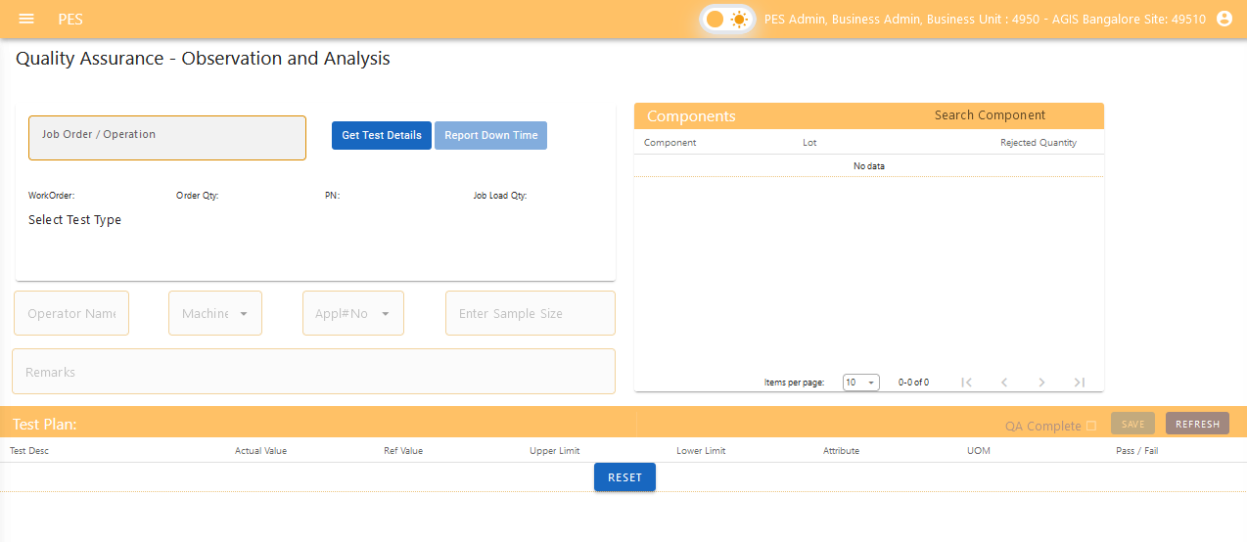

## 1. Job Order Testing Procedure

### 1.1. Test Samples

For each job order, testing must be performed on specific pieces to ensure quality. The following pieces should be tested:

1. **Select Job Order**: Choose the relevant job order from the dropdown menu.
2. Click on  (Get Test Details) Button. The testing details and all the components will be populated.
3. **Select Test Pieces**: Click on the test pieces that need to be tested, which include:

* **First Piece**: The first piece of the production run.
* **Samples**: Any one of the intermediate samples (pieces 1, 2, 3, or 4).
* **Last Piece**: The last piece of the production run.

#### Mandatory Testing

* First Piece
* Last Piece
* Minimum One Sample

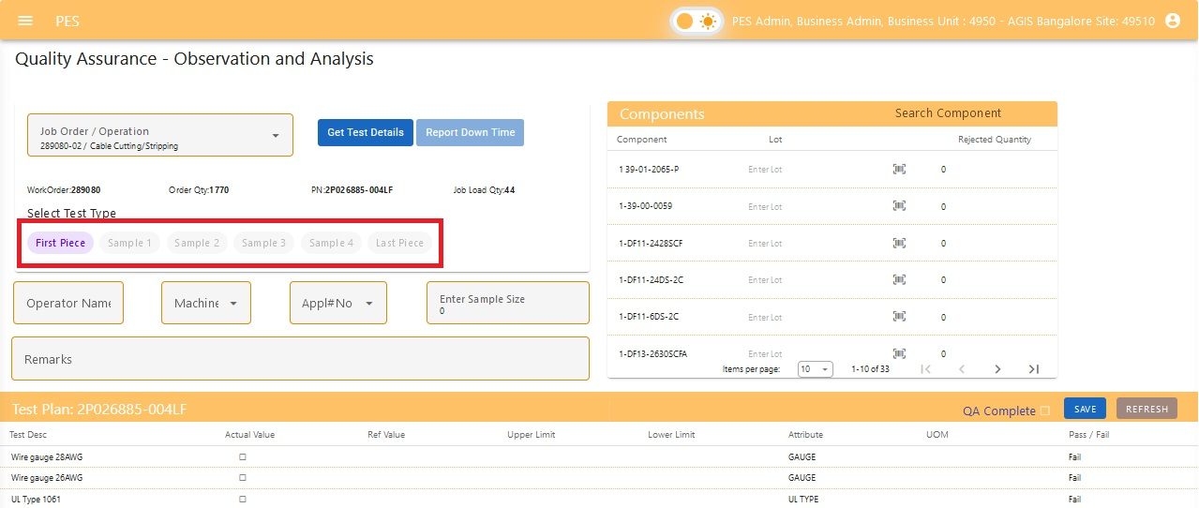

## 2. Component Tracking

### 2.1. Recording Components

For each job order, document the components used in production. The component names will be automatically populated from the backend. Please include the following details for each component used in that specific operation:

* **Lot Number**: The lot number associated with each component used.
* **Rejected Quantity**: The quantity of each component that was rejected, if applicable.

This ensures accurate tracking and reporting of the components directly involved in the current production run.

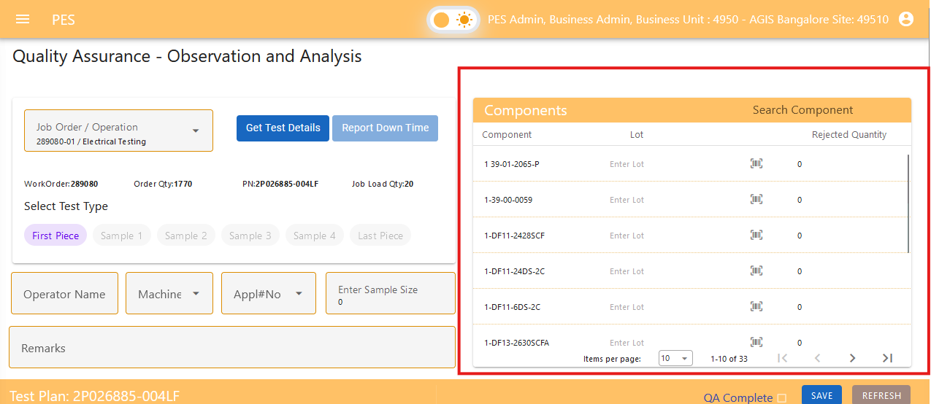

### 2.2. Additional Information

* **Operator**: Name or ID of the operator performing the job.
* **Machine**: Machine used for production it will be a dropdown.
* **Applicator**: Applicator used it will be a dropdown.
* **Sample Size**: No of samples used for testing.
* **Remarks**: Any additional notes or comments relevant to the production or testing.

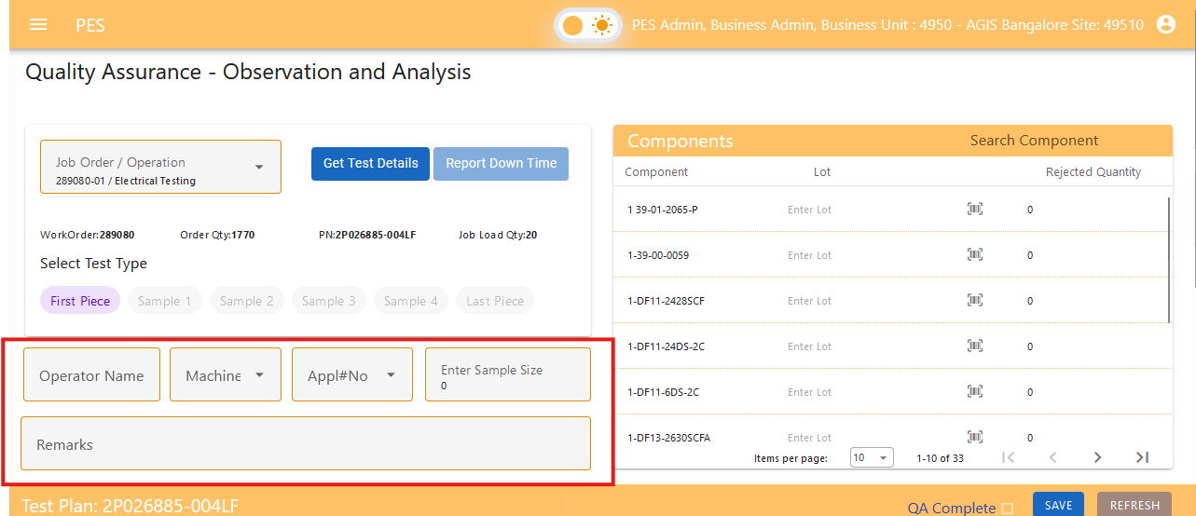

## 3. Testing Details

### 3.1. Test Description

Each test to be performed should will include the following details, which will be populated automatically from the test plan - work order mapping:

* **Test Description**: A brief description of what is being tested.
* **Actual Value**: The value observed or measured during testing (user entry).
* **Reference Value**: The standard value that should be met.
* **Upper Limit**: The maximum acceptable value.
* **Lower Limit**: The minimum acceptable value.
* **Attribute Name**: The specific attribute being tested.
* **Pass/Fail**: The result of the test based on whether the Actual Value falls within the specified limits.

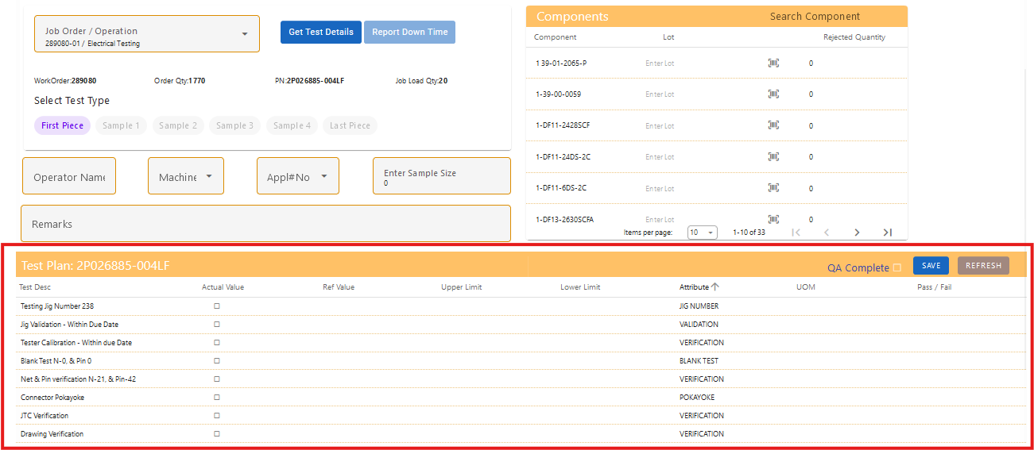

### 3.2. Entering Test Results

1. **Actual Value**: Enter the value observed during testing.
2. **Automatic Population**: All other details, including Test Description, Reference Value, Upper Limit, Lower Limit, and Attribute Name, will be automatically populated based on the mapping done in the test plan - work order mapping.
3. **Pass/Fail Determination**: The Pass/Fail result will be automatically calculated based on the Actual Value entered and the limits specified in the test plan.

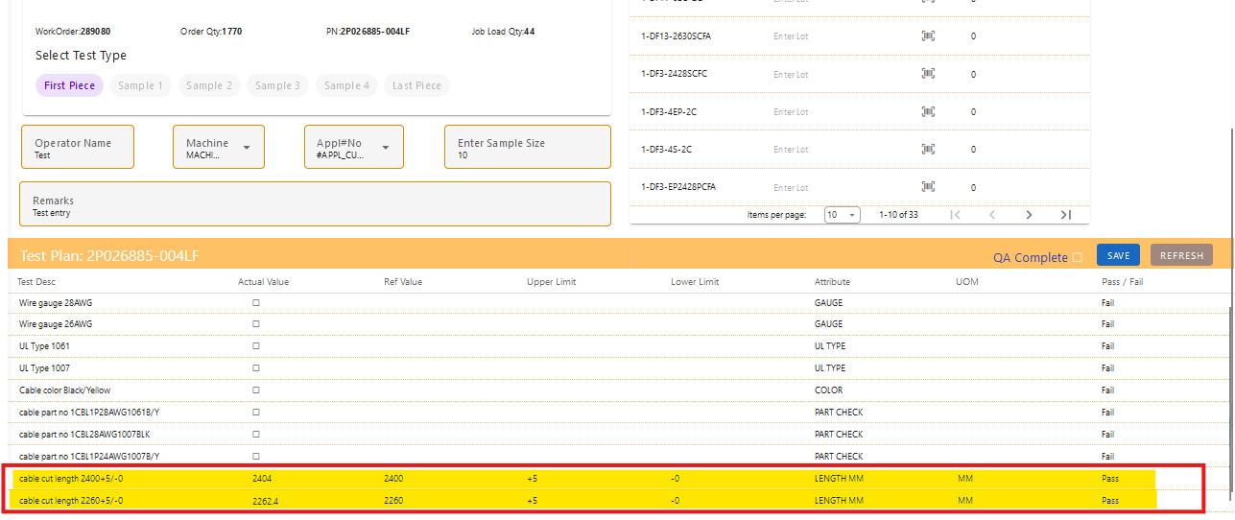

By entering only the Actual Value, the system will automatically fill in the remaining details and determine the Pass/Fail status, ensuring efficiency and accuracy in recording test results.

### 3.3. QA Completion and Record Management

#### 3.3.1. QA Completion Checkbox

1. **QA Completion Checkbox**: After all, required testing for a job order is completed, the QA Completion checkbox must be checked. This action signifies that testing for the current piece is finalized and ready for review.
2. **Automatic Transition**: Once the QA Completion checkbox is checked and the record should be saved, then the system will automatically open next test piece in the sequence for testing.

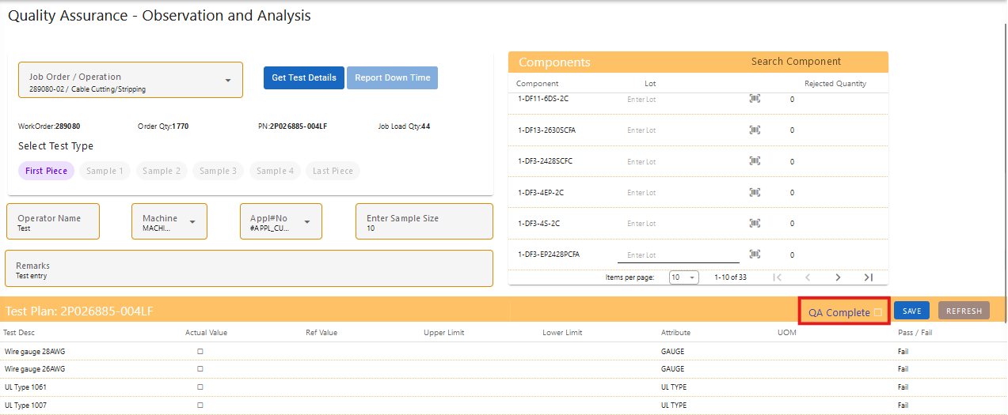

#### 3.3.2. Data Modification Rules

* **If QA is Completed and Saved**: Once the QA Completion checkbox is checked and the record is saved, the data becomes locked and cannot be modified. This ensures that finalized test results are preserved and prevents accidental changes.

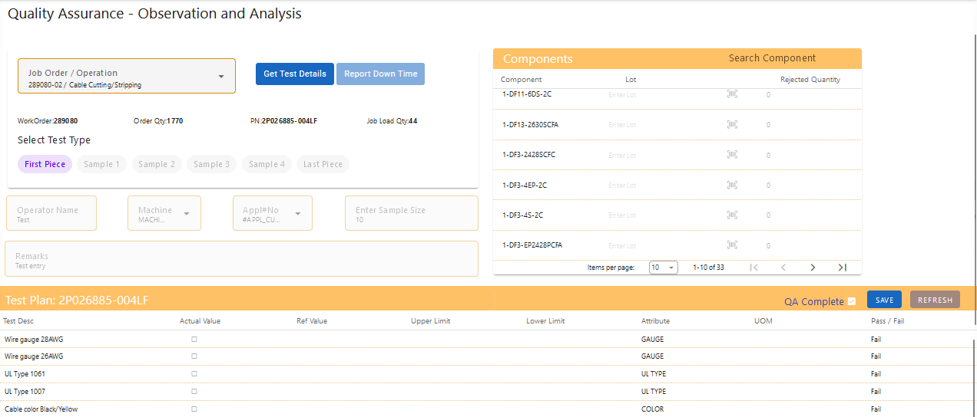

* **If QA is Not Completed**: If the QA Completion checkbox has not been checked, the data remains editable. You can continue to make changes or updates to the test results until the QA process is finalized.

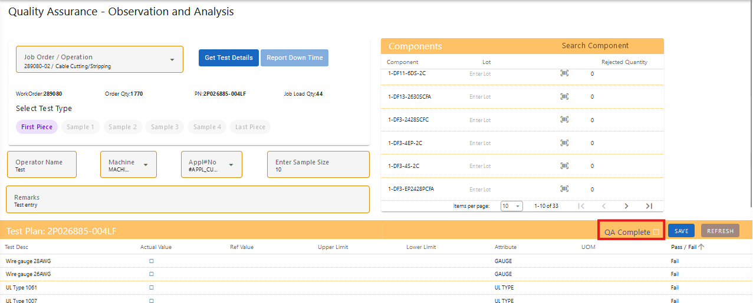

By adhering to these procedures, the system maintains the integrity of the test results and facilitates a smooth transition between test pieces, while allowing flexibility during the testing phase.

### 3.4. Actual Time Recording

* **Actual Start Time**: This timestamp is recorded only when the testing of the First Piece is completed and the QA Completion checkbox for the First Piece is checked. This marks the beginning of the production run.
* **Actual End Time**: This timestamp is recorded only when the testing of the Last Piece is completed and the QA Completion checkbox for the Last Piece is checked. This marks the conclusion of the production run.

These timestamps ensure accurate tracking of the start and end times of each job order based on the completion of QA testing for the first and last pieces.

### 3.5 Report Downtime

From the QA screen, you can report any downtime encountered during production. Follow these steps to add downtime:

1. **Click on Report Downtime**: Click the  "Report Downtime" button on the QA screen.
2. **Enter Downtime Details**:
   * **Reason for Downtime**: Provide a brief description of the issue or reason for the downtime.
   * **Start Time**: Record the time when the downtime started.
   * **End Time**: Record the time when the downtime ended (if applicable).
3. **Save**: After entering the necessary details, save the downtime report.

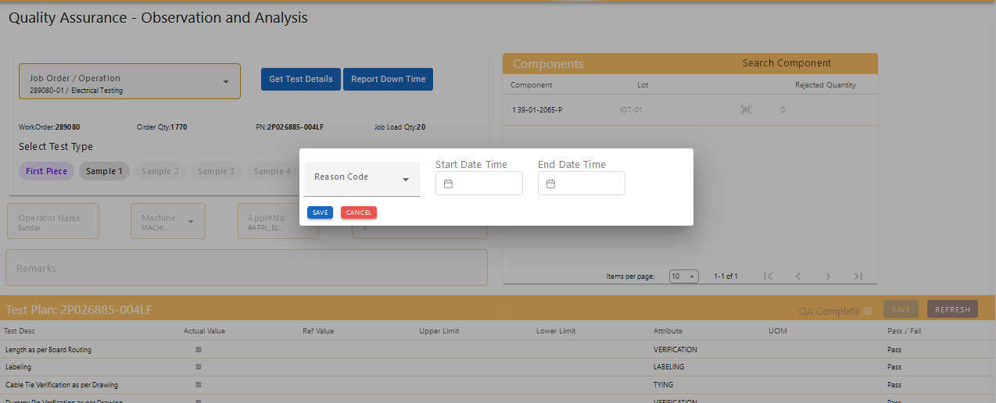

The reported downtime will be added to the production line status, helping to track and manage production interruptions effectively.

### 3.6 Report Production and Rejected Quantity

From the QA screen, you can report production and rejection quantity during conclusion of production when the last operation and last piece testing completed. Follow these steps to add downtime:

1. **Click on Report Quantity**: Click the "Report Downtime" button on the QA screen.
2. **Enter Downtime Details**:
   * **Production Quantity**: Enter the total quantity produced inclusive of reworked.
   * **Rejection Quantity:** Enter the total rejected quantity which is not reworked.
   * **Reworked Quantity:** Enter the quantity that has been reworked after rejection.
   * **Reason:** select the reason from the reason.
3. **Submit**: After entering the necessary details, submit the quantity.

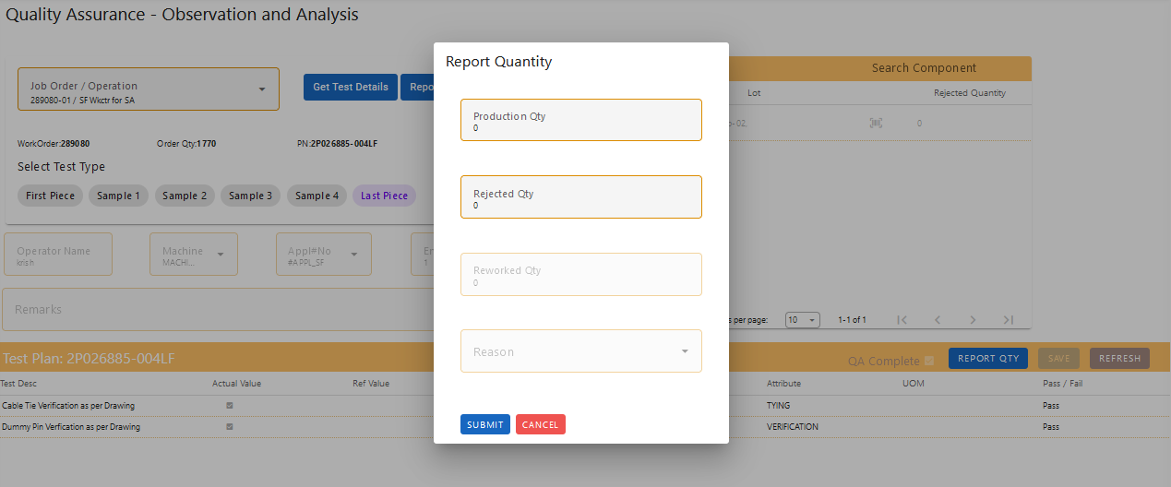

The reported quantities will be added as the job order production and rejected quantities.

# 

### 

# 18. Shop Floor Viewer

The Shop Floor Viewer provides a comprehensive overview of the production status and performance across one or multiple shop floors. This feature allows you to monitor and analyze various metrics to ensure efficient production management. Here’s how you can use the Shop Floor Viewer:

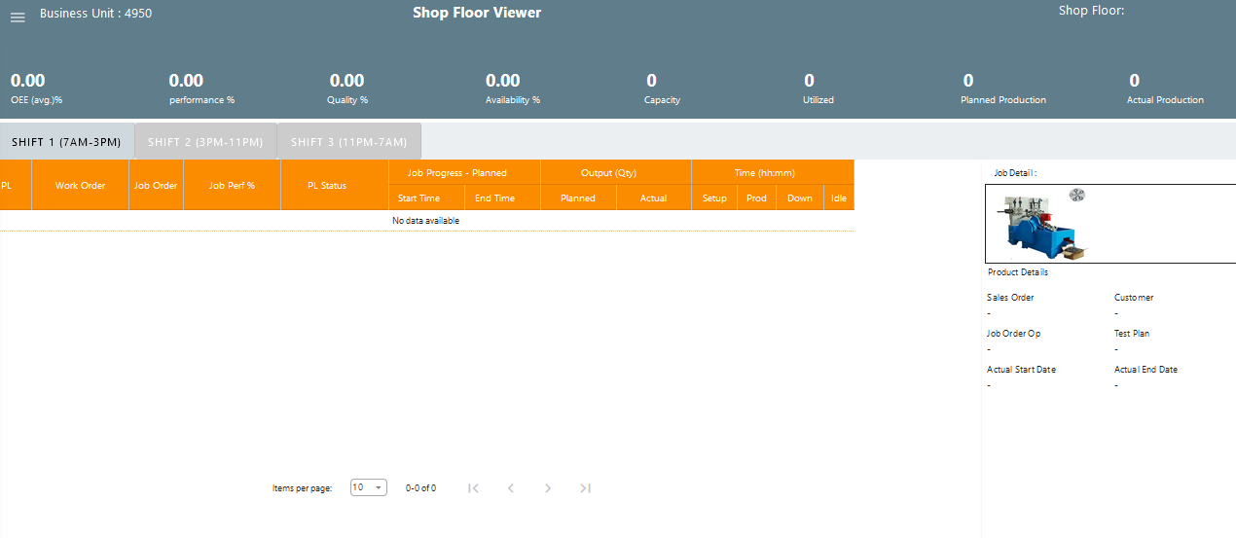

#### Features

1. **Completed Status**: View the status of shop floors that are currently running or have completed production.
2. **OEE (Overall Equipment Effectiveness)**: Check the OEE metric to assess the overall efficiency of the equipment, including availability, performance, and quality.
3. **Availability**: Monitor the availability of shop floor equipment, showing the proportion of time the equipment is operational compared to the total available time.
4. **Performance**: Evaluate the performance of the shop floor, including the speed and output rates relative to expected targets.
5. **Quality**: Review the quality of production, including metrics such as defect rates and compliance with quality standards.
6. **Utilized**: Check the utilization of shop floor resources to determine how effectively they are being used.
7. **Planned Production**: Compare the planned production targets with the actual performance to assess if production goals are being met.
8. **Actual Production**: View the actual production quantities achieved on the shop floor.
9. **Job Order Quantity Reporting**: Report and review the quantities for specific job orders, including any adjustments or updates.

How to Use

1. **Select Shop Floors**: Choose one or multiple shop floors you want to view from the available options.
2. **Select Date**: Specify the date or date range for which you want to view the production data.
3. **View Metrics**: Access the metrics including OEE, availability, performance, quality, utilized, planned production, actual production, and job order quantities.
4. **Analyze Data**: Use the displayed data to analyze production performance, identify areas for improvement, and make informed decisions.

* Click on filter button on top right of the screen

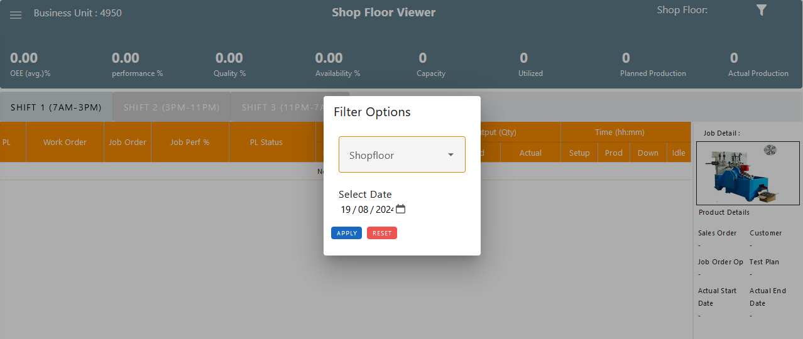

* Select the shop floor and date , then click on apply. Data will be displayed.

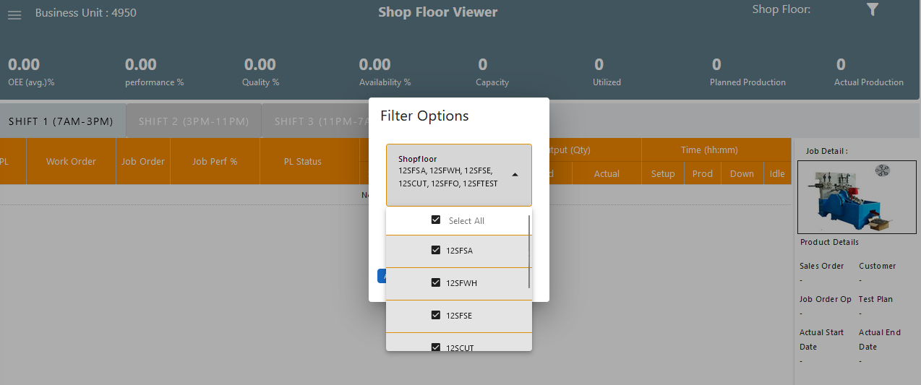

By leveraging the Shop Floor Viewer, you can gain valuable insights into production efficiency and effectively manage your shop floors.

### Shop Floor Metrics Formulas

Here are the formulas used to calculate various shop floor metrics:

#### 1. ****Availability****

Availability measures the proportion of time the equipment or shop floor was available for production compared to the total planned time.

**Availability = (Planned Start Time + Planned End Time / Actual Start Time + Actual End Time​) × 100**

**Note:** The Actual Start Time, Actual End Time will be captured while reporting of test type of first piece and last piece. Planned Start Time, and Planned End Time are calculated while scheduling the job.

#### 2. ****Performance****

Performance measures how well the job performed relative to the planned production quantity.

**Performance = (Job Load Quantity / Job Production Quantity​) × 100**

**Note:** Job Production Quantity refers to the number of units produced, while Job Load Quantity is the number of units planned to be produced.

#### 3. ****Quality****

Quality measures the proportion of good units produced compared to the total production quantity.

**Good Quantity = Job Production Quantity − Rejected Quantity**

**Quality = (Good Quantity / Job Production Quantity​) × 100**

**Note:** Rejected Quantity is the number of units that failed quality control.

#### 4. ****OEE (Overall Equipment Effectiveness)****

OEE combines performance, quality, and availability into a single metric to measure overall production effectiveness.

**OEE = (Performance / 100) × (Quality / 100) × (Availability / 100) × 100**

#### 5. ****Utilized****

Utilized measures whether a shop floor is being used for production based on whether a job has started running.

* If a job started running on the shop floor, it is considered a utilized production line (PL).

#### 6. ****Planned Production****

Planned Production is the total quantity of production planned for the shop floor.

* **Planned Production**: Total quantity planned for production in that shop floor.

#### 7. ****Actual Production****

Actual Production is the quantity of units that were actually completed on the shop floor.

* **Actual Production**: Total quantity of units completed in that shop floor.

By using these formulas, we are effectively monitor and analyzing the performance of the shop floors.

### Data Display Overview

The selected shop floor data will be presented based on the different shifts: S1, S2, and S3. The data will be organized and displayed in a table format, providing detailed insights into the work orders and job orders for each shift. Here’s how to view and interpret the data:

#### 1. ****Data Display****

The data shown will include the following details:

* **Work Order**: The identifier or reference for the work order.
* **Job Order**: The specific job order associated with the work order.
* **Job Performance**: Metrics or statistics related to the performance of the job.
* **Job Status**: The current status of the job (e.g., Running, Completed, Pending).
* **Job Planned Start Time**: The scheduled start time for the job.
* **Job Planned End Time**: The scheduled end time for the job.
* **Job Actual Start Time**: The actual time when the job started.
* **Job Actual End Time**: The actual time when the job ended.
* **Setup Time**: The time taken to set up for the job.
* **Run Time**: The time taken to actually run the job.

#### 2. ****Viewing Data Across Shifts****

* **Shift Tabs**: The data can be viewed for different shifts by switching between the shift tabs:
  + **Shift S1**: Data for the first shift.
  + **Shift S2**: Data for the second shift.
  + **Shift S3**: Data for the third shift.

To view data for a specific shift, click on the corresponding shift tab. The table will update to display the relevant data for that shift.

#### 3. ****Table Layout****

The table will be organized to show the following columns:

* Overall View after selection of Shop floor and Date.

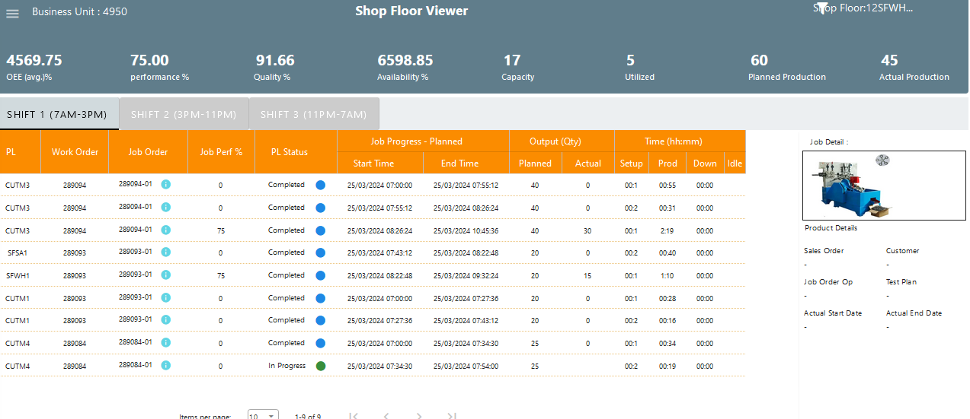

* Job Details display based on Job order’s  (i) button clicked

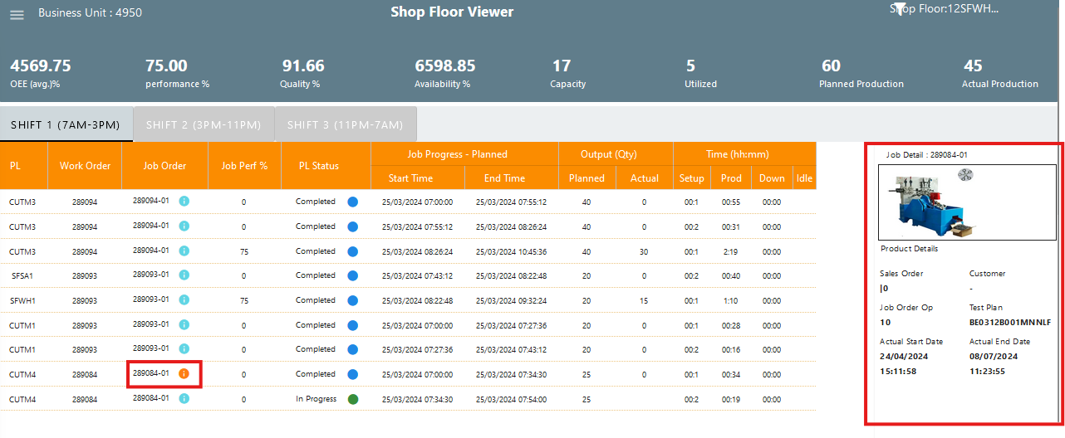

By using the shift tabs and reviewing the data table, you can effectively monitor and analyze job performance and production metrics across different shifts.